Name____________________

World History Final Review Questions

Democracy Unit (prologue & chapter 6)
1. What is the difference between democracy and autocracy?
2. What country invented the concept of democracy?
3. Where did the government type known as a Republic originate?
4. What were John Locke’s key ideas on government?
5. What were Montesquieu’s key ideas on government?
6. This 18th century movement sought to apply the principles of the Scientific Revolution to all aspects of government and society.

French Revolution Unit (Chapter 7)
7. He was the King at the beginning of the French Revolution.
8. The Third Estate in France consisted mainly of ________
9. What were the main causes of the French Revolution?
10. How did the guillotine emphasize equality?
11. What was significant about Bastille Day (Storming of the Bastille?)
12. He seized power (coup d’ etat) in France after the Reign of Terror.

Industrial Revolution Unit (Chapter 9)
13. Where did the Industrial Revolution begin?
14. Why was Britain able to industrialize first? (CAN BELCH)
15. What were some positive effects of the I.R.?
16. Utopian ideas attempted to achieve what?
17. The economic system that believes in a competitive market with the goal of individuals making a profit? (The U.S. has this system)
18. The economic system that in which all means of production are owned by the workers/people; private property no longer exists. All goods & services shared equally
19. The key invention during the I.R. that changed manufacturing and transportation was?
20. People joined these organizations to fight for better working conditions and wages.

Imperialism Unit (Chapters 11 & 12)
21. A policy in which a strong nations seeks to dominate other countries politically, economically and socially?
22. Why did countries want to Imperialize?
23. What country remained independent because of the Battle of Adowa?
24. South Africa was racially divided under British & Dutch control and the races were separated under what racist policy?
25. He was the leader of the ANC who protested Apartheid laws & was jailed for 27 years. He also became the first black president of South Africa.
26. India was colonized by what country?
27. How did Gandhi rebel against the British?

WWI Unit (Chapter 13)
28. What were the MAIN causes of WWI? What was the Immediate Cause?
29. What is an example of total warfare?
30. Most battles along the Western Front took place in what country?
31. He was the president of the U.S. during WWI and was known for the Fourteen Points?
32. What was the name of America’s policy on joining the war in 1914 and 1939? What countries where victorious in WWI?
33. This treaty ended WWI and eventually led to WWII? Why?

Russian Revolution Unit (Chapter 14)
34. What was going on in Russia towards the end of WWI?
35. This person brought communism to Russia and promised the people “Peace, Land & Bread.”
36. What Soviet Leader was responsible for approximately 20 million deaths?
37. What happened on Bloody Sunday?
38. What happened as a result of the Treaty of Brest-Litovsk?
39. How did Rasputin influence the Russian Government (Czar & Czarina)?

WWII Unit (Chapters 15 & 16)
40. What is Fascism? What key term does Fascism stress?
41. Giving in to Hitler’s demands to avoid war was called what?
42. The invasion of this country led to the start of WWII?
43. What was Hitler’s lightning war technique called?
44. What event brought the U.S. into WWII?
45. Who was the commander of the D-Day invasion and later became President?
46. He was the U.S. President during most of WWII?
47. Why did President Truman decide to drop the Atomic Bombs on Japan?

Cold War (Chapter 17)
48. What 2 main superpowers were involved in the Cold War?
49. What was the purpose of the Marshall Plan and the Truman Doctrine?
50. The name of Truman’s policy to stop the spread of Communism?
51. Churchill’s term for the division of Communist Europe and Democratic Europe.
52. Why was the Berlin Airlift necessary?
53. Who made the statement, “Communism and Capitalism can’t coexist in the same world?”
54. What was NATO? What did European Communist nations create in response?
55. This was built to stop East Berliners from escaping/leaving to West Berlin?
56. What was De-Stalinization? What Soviet leader helped with this process?
57. What October event escalated the space race?
58. What two groups fought in the Chinese Civil War? What were the results?
59. This leader led the Communist party in China?
60. What was the Cultural Revolution in China?
61. Why did the U.S. back South Korea in the Korean War?
62. What were the results of the Korean War?
63. What event led to the start of U.S. involvement in the Vietnam War?
64. Who was Ho Chi Minh?
65. What were the results of the Vietnam War?
66. Describe the Domino Theory and how it relates to the U.S. Foreign policy during the Cold War?
67. Who were the Vietcong?
68. What was Vietnamization?
69. What was the objective of détente? How did this change the policy of brinkmanship?
70. The Soviet Union collapsed in what year?
71. Know the difference between Capitalism & Communism
72. What was the Cuban Missile Crisis? How did this intensify the Cold War?
73. What was the Star Wars Program know and who initiated it?

Map Locations to Know:
- England/Great Britain 10. Poland 19. Pakistan
- France 11. China 20. Atlantic Ocean
- Belgium 12. Vietnam 21. Pacific Ocean
- Russia/Soviet Union 13. N. Korea 22. Serbia
- Italy 14. S. Korea 23. Austria
- Germany 15. Japan 24. Czechoslovakia
- Switzerland 16. Taiwan 25. Turkey
- Afghanistan 17. India 26. Cambodia
- Mediterranean Sea 18. Philippines 27. Indian Ocean
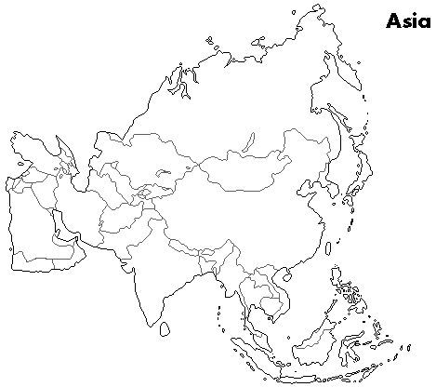

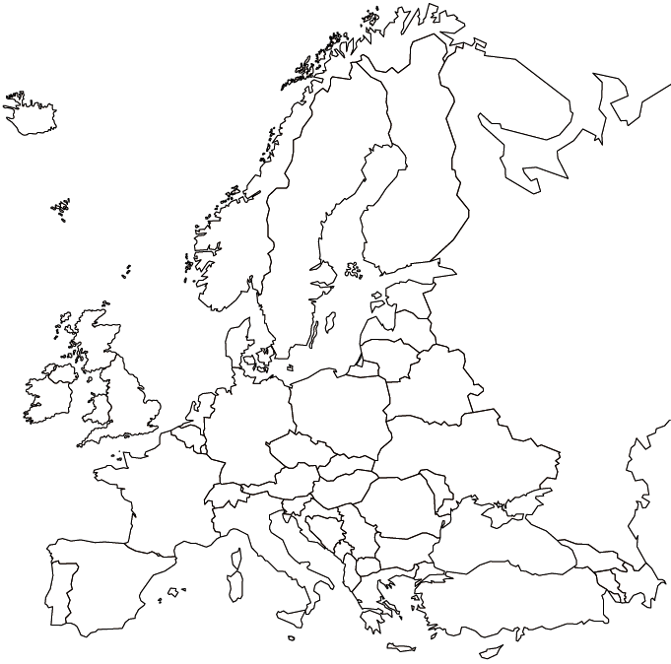
Europe

