**Name: _________________ Period:______**

**The Inventors of the Industrial Revolution**

***Directions:* For each inventor write 7 facts about how each inventor brought massive social, cultural, and economic changes.**

**1. Thomas Edison**

[](http://www.clker.com/clipart-6940.html)

[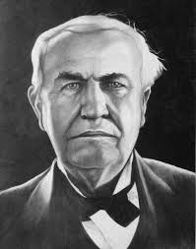](http://images.google.com/imgres?imgurl=http://i17.photobucket.com/albums/b95/mrzshoe/Edison2C.jpg&imgrefurl=http://www.physicsforums.com/showthread.php%3Ft%3D163625%26page%3D5&usg=__eYcU32rjQl2HXXV76uxchc2eY54=&h=650&w=511&sz=66&hl=en&start=43&tbnid=kq7K2k1jIM802M:&tbnh=137&tbnw=108&prev=/images%3Fq%3DThomas%2BEdison%26gbv%3D2%26ndsp%3D20%26hl%3Den%26sa%3DN%26start%3D40)

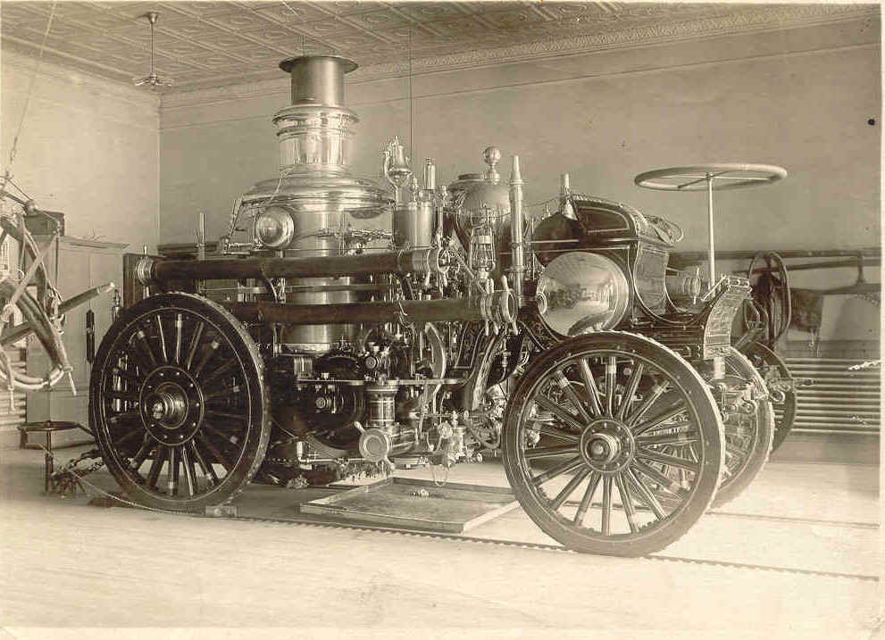

1. **James Watt**

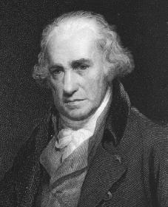

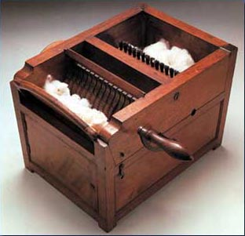

1. **Eli Whitney**

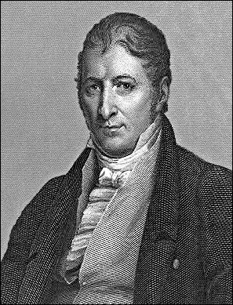

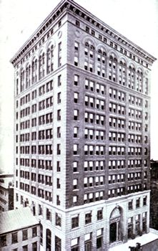 **4. Henry Bessemer**

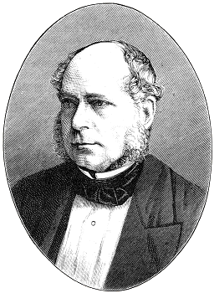

**5. Louis Pasteur**

