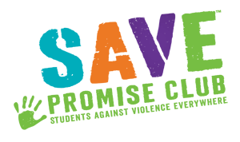 The Daters Bill of Rights
- I have the right to refuse a date from anyone without feeling guilty.
- I have the right to ask anyone for a date without feeling rejected if the answer is no.
- I have the right to control my own decisions, actions, and to know what I want for myself.
- I have the right and the responsibility to make both positive and healthy decisions for myself and the other people I care about.
- I have the right to deny physical closeness with someone; ‘I have the right to say no.’
- I have the right to start a new relationship slowly and the right to say that I want to get to know that person first.
- I have the right to always be myself without changing anything about me.
- I have the right to exit a relationship when my feelings change or when I want something else for myself.
- I have the right not to blame myself if my partner wants to end our relationship.
- I have the right to find a kind, equal, and loving partner in any and every relationship.
- I have the right not to be dominated or abused by anyone in any relationship.
- I have the right to act anyway that I choose necessary depending on the situation.
- I have the right to live my life free from violence, abuse, and neglect.
- I have the right to always be honest with myself and the other people in my life.

____Signature:_________________________________________________________________

890× 667

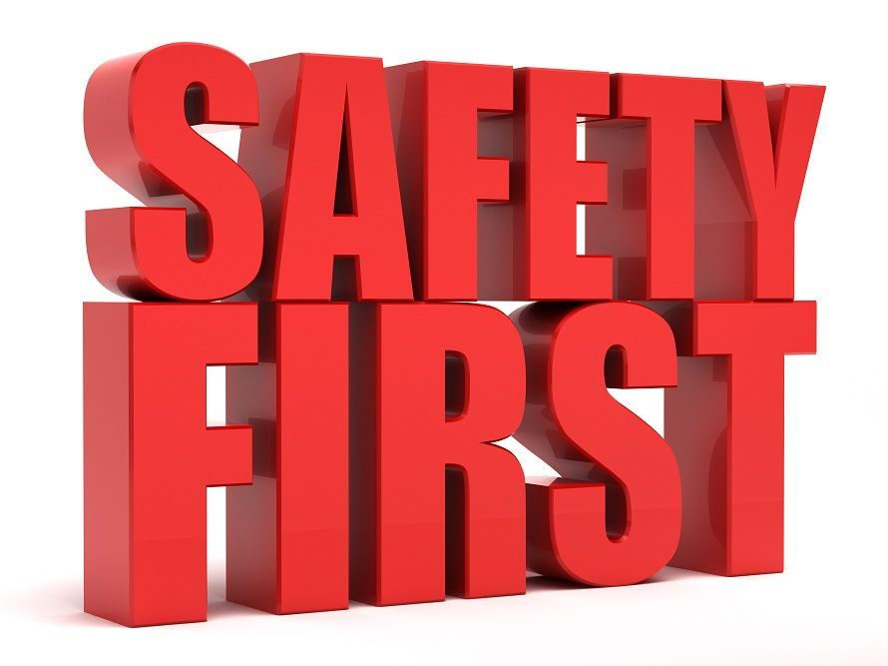
The 7 simple rules of staying safe on a first date
- Do communicate your plans with someone you trust. ...
- Do meet in a public place. ...
- Do take your cell phone. ...
- Do pre-plan your route home. ...
- Do leave if you feel uncomfortable. ...
- Don't leave your drink or your personal belongings unattended. ...
- Do not meet at your house or place of work. ...
Some Helpful Resources
- Law Enforcement Agencies (911)
- National Domestic Violence Hotline (1-800-799-SAFE)
- National resource Center for Domestic Violence (1-800-537-2238)
- National Runaway Switchboard (1-800-621-4000)
- Child Help USA Child Abuse Hotline (1-800-422-4453)
- Suicide Prevention Help Line (1-800-227-8922)

