Culture and Social Class Article

Social class is forever
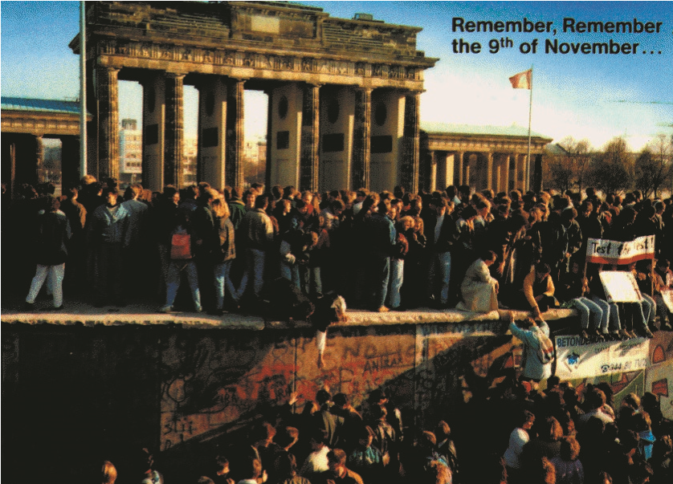
Political and economic systems come and go, races are socially constructed and deconstructed, empires rise and fall, cultural traditions evolve and change; but the common factor through all of these myriad expressions of human social organization is socio-economic class. Social class has been addressed in philosophy, economics, and political science for thousands of years in the traditions of several of the great civilizations. This chapter treats it as a cultural and social phenomenon.
Social class did not disappear on November 9, 1989. Some political scientists, such as Francis Fukuyama, suggested that the fall of the Berlin Wall and the defeat of the Soviet Union in the Cold War indicated that capitalism and liberal democracy were destined to become the dominant economic and political forms throughout the world. Communism was associated with class conflict and sought to polarize the classes in order to imbue the working class with a consciousness of its situation and its options within the capitalist system. However, the apparent defeat of communism did not render everyone suddenly middle class,
Fall of the Berlin Wall
classless, or satisfied with their lot in life; fundamental differences in classes continue to exist as a force with modern, liberal democracies. Capitalism is heralded as the best of all economic systems, so far, but has inherent problems (“contradictions”) connected to social class evolution and change. In this chapter, I will outline the cultural and social forces at work in maintaining a class society, and the social effects of class distinctions.

Classism
embeddedness in our subject matter means that we have to be very careful to recognize our class biases and class-based perspectives.  Psychologists–academic as well as applied–work in middle or upper-middle class | Disdain for, but fascination with, the royalty that we escaped.
We are all of and in a social class. We are of the class that our parents occupy, born into it just as we were born into a nation and thrown into its culture. We don’t deserve our class (or national) ascribed status, regardless of what it is (in contrast to cultures that believe in reincarnation). We in the class that we rose to or fell to as adults, although this achieved class standing may be more expectational than realized prior to completing our educations. When we discuss class (just as when we discuss culture), we are speaking from the perspectives of our own class affiliations. There is no neutral, outsider perspective in the idealized sense of the anthropologist performing field research; we are participant observers. This social settings that mold middle class values, regardless of the class background of the psychologist. One is hard-pressed to imagine a scientific discipline that is working class in its attitudes, values, activities, and settings. Lacking an unbiased approach to the subject matter, we must be vigilant to classist judgments.
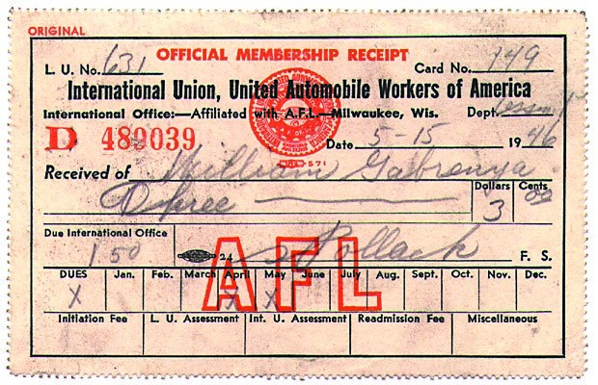
While scientist can and must strive to be fair-minded in approaching this subject, normal people are not bound by scientific values, and often exhibit classist attitudes and behaviors. America is an anti-class society that, at once, believes all people are equal, realizes they are not, disdains inherited wealth and European royalty, is fascinated by the “lifestyles of the rich and famous,” resents the elite’s power and privilege, yet seeks to have such power and privilege. American society is at once open, fair, and mobile; yet closed, unfair, and established. Anyone can become rich or powerful; yet few actually rise precipitously from modest beginnings. In the end, class is power:
“Categorization of groups of people into upper and lower strata, into superior and inferior, is done by those who require such categorization to maintain their power, prevent others from obtaining an equal share of resources, and sustain the myth of superiority (Williams, 1993; in Lott, 2002).” | Working class family. A receipt for the author’s father’s union dues immediately following WWII. Unions are one of the few sources of power available to working class people.
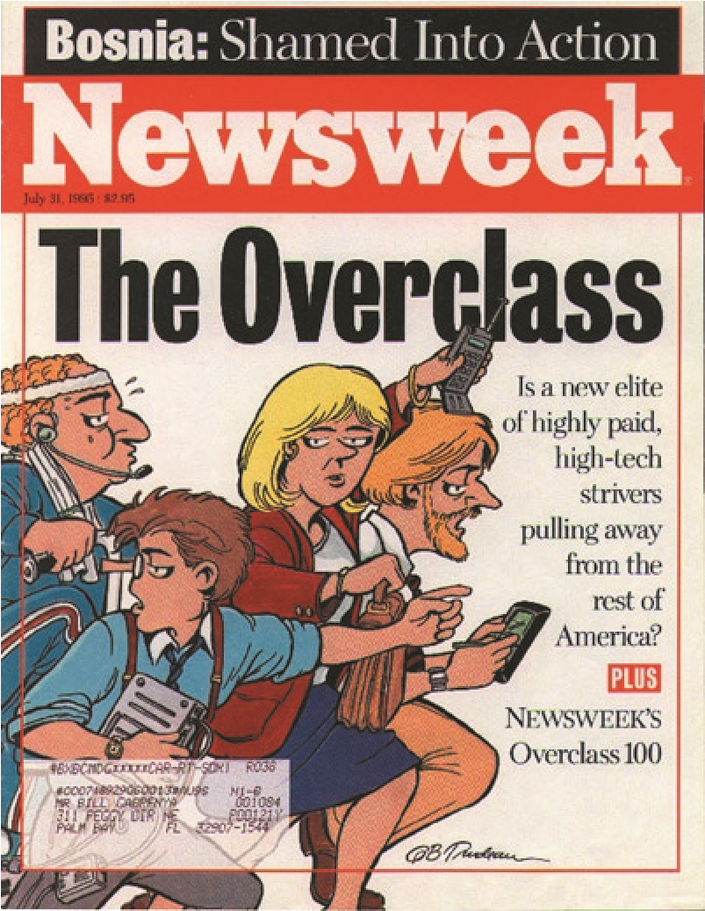
The manner in which psychologists, normal people, government, and institutions treat the lower classes is termed “cognitive distancing” by Lott (2002). She shows how this distancing (a poor term) is expressed in the way the poor are treated in the domains of housing, health care, tax policy, access to legal resources, and social value in the society. Taken together, these “distancing” have some of the features of other “isms,” such as racism and sexism.

Defining Social Class
Social class is conceptualized in various ways as a function of the theoretical or political orientation of the writer, much like “personality” is defined differently by psychologists who hold different theoretical perspectives. To Karl Marx, people’s social class membership was determined by their relationship to the means of production, that is, by what they did within a society’s way of producing goods and services. Marx saw two classes, capitalists and workers. Capitalists owned the means of production (factories, businesses, etc.) and workers labored in them. Other Marxists added a third class: the bourgeoisie (boo-zhwah-zee), composed of small businesspersons, experts, and the major professionals (doctors, lawyers, professors). The bourgeoisie shares features with both owners and workers. Marxism is partly an analysis of the relationships among these two or three classes in the context of supposedly-inevitable changes in economic and social systems.
Sociologists often use a simpler and less ideologically loaded approach to social class, conceiving it as one kind of social strati- | Inventing the Overclass. Newsweek’s attempt to identify a new social class category (based on a Doonesbury cartoon).
You Are Where You Live (YAWL)
Your zip code tells marketing folks what to pitch to you. See http://cluster2.claritas.com to see who you are from a marketing point of view.
fication. Social stratification is the ubiquitous characteristic of societies to organize people in a hierarchy of levels or “strata” on a variety of dimensions. These dimensions include power, wealth, social status, education level, prestige of one’s occupation, social standing, and many others. Social class is usually studied by comparing people along three closely related stratification continuums, educational attainment, occupational prestige, and sometimes wealth or income. Using this approach, Hollingshead developed a commonly-used method for combining education and occupation into a single measure, the 5-level Hollingshead Index. The U.S. Census Bureau combines education, occupation, and wealth in its index. Complex and comprehensive measures of occupational prestige have been generated by empirical research, the most well-known of which were presented by Treimen and his colleagues, e.g.,
Ganzeboom and Treiman’s International Occupational Prestige Scale. For example, university professors have an average prestige score of 78 on this scale (psychologists are probably above other professors for obvious reasons), auto body workers are 41, and so on for hundreds of occupations.
Do people know what class they are in? Not really, at least not in America. Most working class Americans believe they are middle class, and American political discourse emphasizes the idea that “regular people” are middle class. This middle class bias is deeply rooted in American culture and may explain the failure of the United States to form a labor party. American psychology, a middle class enterprise, is seemingly equally blind to class. However, social scientists are trained to ask the question, “what’s really going on here?” and take a hard look at class dynamics in ways that often make lay people uncomfortable.

Class in America
Class and class conflict pervade the history of the United States, as well as all
Western nations. The decision to import large numbers of African slaves in the
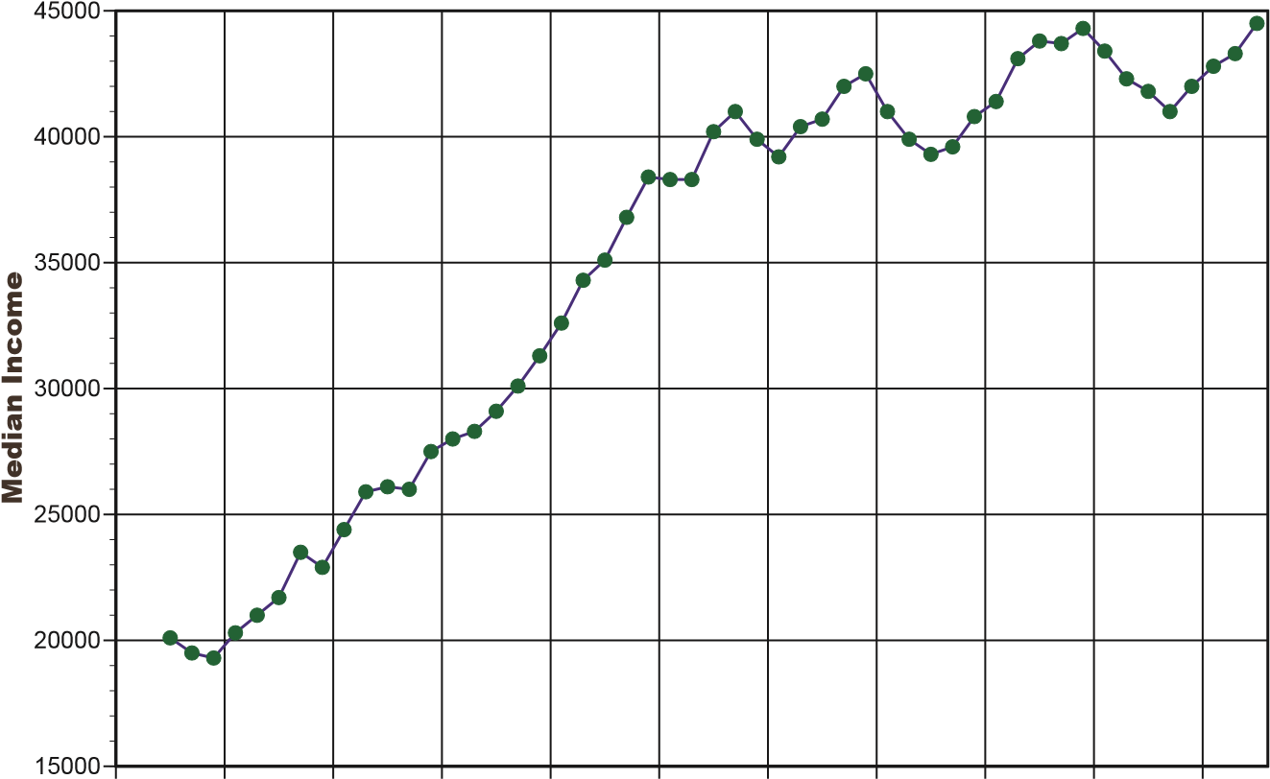
1600s has been attributed, in part, to Southern land owners’ fear of the power of a growing, dissatisfied white landless laboring class, the “giddy multitude.” The subsequent American revolution had a significant class conflict component, and the 1987 (i.e., current) Constitution is often portrayed as a reaction against the gains made by the working classes after the revolution. The 19th Century battles over the gold versus silver standards, the rise of the Progressive movement in the early 1900s and the struggles of labor unions for well over 100 years
are chapters in American class dynamics. 1945 1950 1955 1960 1965 1970 1975 1980 1985 1990 1995
Median Family Income. Note the steady increase in income during the post-WWII era up to 1970, then the slower increase with larger downswings
during recessions.

Economists and sociologists track trends in the distribution of wealth and other stratification variables (e.g., education) over time. Key variables include the poverty rate, the distribution of wealth, and the gap between the rich and the poor. Political scientists are interested in how political decisions and economic policy changes (e.g., tax policy) affect these variables.
In 1940, near the end of the Great Depression, over 50% of Americans lived in poverty. The figure fell steadily until about 1970 and bottomed out at 11% in 1973. It has varied in the range of 11% to 15% since then. (These and other data in this section are from the U.S. Census Bureau unless otherwise noted.) Family income rose precipitously from WWII to 1970, then rose more slowly with periodic large declines since. The rapid decline of poverty and increase in income from the 1940s to about 1970 can be attributed to the prosperity that followed WWII, a period during which
1970 1975 1980 1985 1990 1995 2000
Inceasing Income Gap. Median household income for the lowest and highest
20
40
60
80
100
120
140
160
Median Household Income
Lowest Quintile
Highest Quintile
the U.S. controlled the world financial
system and dominated manufacturing.

By 1970, the relative degree of U.S. dominance had declined and the problem of energy supplies had become acute.
The disparity between rich and poor—economic stratification—showed a very different pattern from that of poverty and income. Up to 1969, the disparity generally declined, but it has increased rapidly and consistently to the present. The boom years of the 1990s witnessed the greatest increase in the size of the income gap, teaching us this important lesson: social class in America is more, not less, important in the post-Cold War era. This increasing disparity poses a serious threat to American democracy and the success of a pluralist society.

