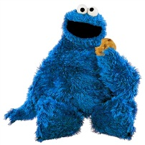Cookie Monster thinks that a special juice will increase the productivity of cookie making. He creates two groups of 50 pastry cooks each and assigns each group the same task (in this case, they're supposed to mix cookie dough). Group A is given the special juice to drink while they mix. Group B is not given the special juice. After an hour, Cookie Monster counts how many cookies each group has made. Group A made 1,587 cookies, Group B made 2,113 cookies. | Identify the:  1. Control Group  2. Independent Variable  3. Dependent Variable  4. What should Cookie Monster’s conclusion be?  5. How could this experiment be improved?
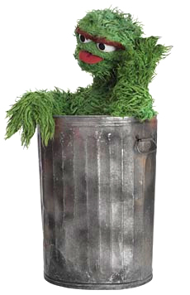Oscar notices that his can is covered in a strange green slime. His friend Elmo tells him that coconut juice will get rid of the green slime. Oscar decides to check this this out by spraying half of his can with coconut juice. He sprays the other half of the shower with water. After 3 days of "treatment" there is no change in the appearance of the green slime on either side of the can. | 6. What was the initial observation?  Identify the-  7. Control Group  8. Independent Variable  9. Dependent Variable  10. What should Oscar's conclusion be?
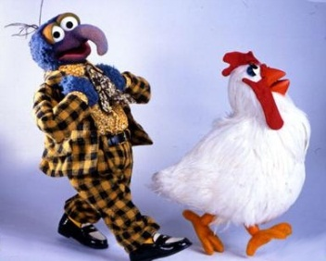Gonzo believed that chickens exposed to radio-waves will become extra strong. He decides to perform this experiment by placing 10 chickens near a radio for 5 hours. He compared these 10 chickens to another 10 chickens that had not been exposed. His test consisted of placing a heavy block of wood in front of the chicken’s food. He found that 8 out of 10 of the radio-waved chickens were able to push the block away. 7 out of 10 of the other chickens were able to do the same. |  | Identify the-  11. Control Group  12. Independent Variable  13. Dependent Variable  14. What should Gonzo's conclusion be?  15. How could Gonzo's experiment be improved?
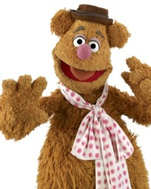Fozzie was told that a certain itching powder was the newest best thing on the market, it even claims to cause 50% longer lasting itches. Interested in this product, he buys the itching powder and compares it to his usual product. One test subject (Kermit) is sprinkled with the original itching powder, and another test subject (Miss Piggy) was sprinkled with the experimental itching powder. Kermit reported having itches for 30 minutes. Miss Piggy reported to have itches for 45 minutes. |  | Identify the-  16. Control Group  17. Independent Variable  18. Dependent Variable  19. Explain whether the data supports the advertisements claims about its product.
Beaker is working on a science project. His task is to answer the question: "Does Rogooti (which is a commercial hair product) affect the speed of hair growth". His friends are willing to volunteer for the experiment. |  | 20. Describe how Beaker would perform this experiment. Identify the control group, and the independent and dependent variables in your description.

