Reign of Terror: The Committee of Public safety
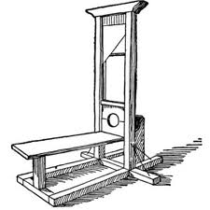
Background: The French Revolution began in 1789. The Committee of Public Safety, headed by Maximilian Robespierre, was established to protect the Revolution from its enemies. The Committee took over the National Convention and Robespierre ruled as a dictator. He was responsible for many deaths during the period known as the Reign of Terror.

Prompt: Was the main goal of the Committee of Public Safety to “protect the Revolution from its enemies”?

Paragraph Structure:
- Topic sentence: Introduce topic and the controlling idea (thesis). This is where you answer the prompt given.
- Background info: Include any information about the topic that is necessary to understand your evidence.
- Supporting ideas (evidence/concrete details)-use the documents to find evidence that directly supports your thesis. Make sure to cite what document the evidence is from .
- Concluding sentence: Lets the reader know the paragraph is ending. Restate the thesis or controlling idea of your paragraph.

Paragraph 1
- Topic/Background info:

- Thesis/Controlling Idea:

- Supporting Ideas (cite document and provide commentary/explain):

Paragraph 2
- Topic Sentence (still related to the thesis and gives introduction to the paragraph)

- Supporting Ideas (cite document and provide commentary/explain )

- Concluding sentence

