Pop Culture & Self Concept Google Slides Project
Presentation Rubric
Name: ____________________________________________________ Period:_________________________
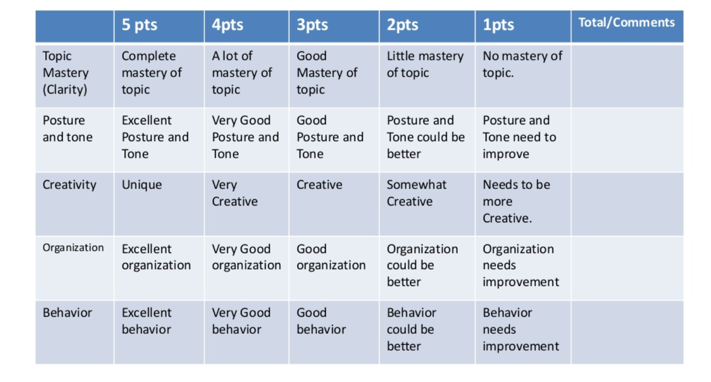
Length of time for presentation: ________________________ ( should be around 3-5 minutes)

Overall Score: __________________/ 25

Notes:______________________________________________________________________________________________________________________________________________________________________________________________________________________________________________________________________________________________________________________________________________________________________________________________________________________________________________________________________________________________________________________________________________________

Pop Culture & Self Concept Google Slides Project Rubric
Name: ____________________________________________________ Period:_________________________
Slides Info | 10 | 9 - 7 | 6 – 4 | 3 - 1 | 0 | Total
Slide 1  Title | Name, Period, & Template Design | Name, & Period | Name only | Period only | No name, no period
Slide 2  Topic 1 | 5-6 sentences & 2 pictures related to the topic | 3-4 sentences & 2 pictures related to the topic | 2-3 sentences & 1 picture related to the topic | 1-2 sentences & 1 to no pictures related to the topic | No senctences & no pictures related to the topic
Slide 3  Topic 2 | 5-6 sentences & 2 pictures related to the topic | 3-4 sentences & 2 pictures related to the topic | 2-3 sentences & 1 picture related to the topic | 1-2 sentences & 1 to no pictures related to the topic | No senctences & no pictures related to the topic
Slide 4  Topic 3 | 5-6 sentences & 2 pictures related to the topic | 3-4 sentences & 2 pictures related to the topic | 2-3 sentences & 1 picture related to the topic | 1-2 sentences & 1 to no pictures related to the topic | No senctences & no pictures related to the topic
Slide 5  Topic 4 | 5-6 sentences & 2 pictures related to the topic | 3-4 sentences & 2 pictures related to the topic | 2-3 sentences & 1 picture related to the topic | 1-2 sentences & 1 to no pictures related to the topic | No senctences & no pictures related to the topic
Slide 6  Topic 5 | 5-6 sentences & 2 pictures related to the topic | 3-4 sentences & 2 pictures related to the topic | 2-3 sentences & 1 picture related to the topic | 1-2 sentences & 1 to no pictures related to the topic | No senctences & no pictures related to the topic

Project Submitted Ontime to Google Classroom: ___________ / 20

Overall Total Score: _______________ / 80

