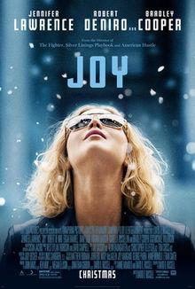
Name: ______________________________________ Period:____________
Joy Movie Questions
- At the beginning of the movie, who is narrating? ________________________
- Joy invents what in high school? _____________________________________
- “________________ continuous loops of cotton.”
- How many questions lead to Trudy’s “financial worthiness? ________________
- How much does the mop cost?__________________
- Joy stands outside of what store demonstrating the mop when police stop her? ______________________________________________________________
- Neil Walker says he was the manager for what major company? _____________________________
- Neil Walker asks Joy to make how many mops (units) for her 1st order? ________________________
- Joy witnesses an actual caller during her visit “Sharon from ______________________”.
- Who is really the actual caller?____________________________________
- QVC stands for? ____________________________________________
- What is the name of her mop as it appears on QVC? _______________________________
- Who calls Joy from New York while she appears on QVC for 1st time demonstrating the mop? __________________________________________________________________________
- What family member of Joy’s dies? _____________________________________________
- Who does Rudy send to California to talk to Gerhardt and how much does she pay him?
_________________________________________________________________________
- When Joy was in California to talk to Gerhardt, where does she hide & what did she find out? _______________________________________________________________________
- Joy has to file for ___________________________________ to stop losing money?
- Joy went to what state to talk to Derek Markham? _______________________________
- Joy went on to invent what for a cleaner closet? _________________________________
- Joy went on to own what company?___________________________________________
- Who does Joy meet with in her office at the end of the movie?_______________________
- How do you feel after watching the movie?
________________________________________________________________________________________________________________________________________________________________________
- If you were Joy what would you do differently?
________________________________________________________________________________________________________________________________________________________________________

