Name: _________________________ ___________ Period: __________________

Unit 3 - The Industrial Revolution Begins - DBQ

*This task is based on the accompanying documents. Some of these documents have been edited for the purpose of this task. This task is designed to test your ability to work with historic documents. As you analyze the documents, take into account both the source of the document and the author’s point of view

Historical Context
The Industrial Revolution refers to the greatly increased output of machine-made goods that began in England in the 1700’s within the textile industry. Before the Industrial Revolution, people wove textiles by hand. Beginning in the middle of the eighteenth century, machines did this and other jobs as well. Greatly improved farming methods resulted in an agricultural revolution that paved the way for changes in manufacturing techniques. There were many reasons why the Industrial Revolution began in England and then spread to continental Europe and North America.

Directions
The following question is based on the accompanying documents. As you analyze the documents, take into account both the source of the document and the author’s point of view.

Document 1: England’s resources circa 1700.

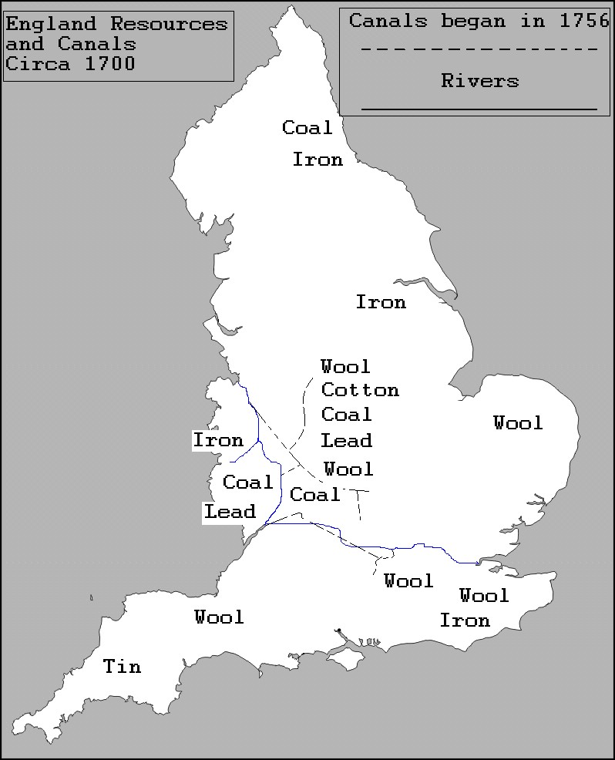

Q: According to the map, what resources did England have that were needed for industrialization?

Document 2: This excerpt is from a witness’s description before the Factory Commission in 1883.

You have been a witness of the operative (working) class in these parts; you have seen it grow from nothing into a great body in the space of a few years; how was it recruited?...A good many from the agricultural parts…people left other occupations and came to spinning for the sake of the high wages

Q: Why were factory workers available?

Document 3: The following excerpt from Adam Smith’s Wealth of Nations written in 1776 describes the assembly line used in factories.

“I have seen a small manufactory [factory] of this kind where ten men only were employed, and where some of them performed two or three distinct operations…They
could…make among them…upwards of 48,000 pins in a day…But if they had all wrought [worked] separately and independently…they certainly could not each of them have made twenty…in a day.”

Q: According to Smith, why were workers in a factory so productive?

Document 4: Here is an excerpt from Landmarks in English Industrial History, a book written by George Warner in 1899 (London: Blackie and Son, 1924).

England…has been fortunate in processing the natural conditions necessary for

success…We recognize that England is rich in these advantage, that she has coal and iron
lying close together, that her sheep give the best wool, that her harbors are plentiful, that she is not ill-off for rivers, and that no part of the country is father than seventy miles from the sea .

Q: How did geography help England industrialize?

Document 5: This excerpt is from The Industrial Revolution by Thomas S. Ashton (Oxford University Press, revised edition, 1962).

...systematic thought lay behind most of the innovations in industrial practice.
Invention…rarely thrives in a community of simple peasants or unskilled manual laborers: only when division of labor has developed…does it come to harvest. The stream of English scientific thought was one of the main tributaries [causes] of the industrial
revolution…discoveries in different fields of activity were linked together…

Q: How did innovation lead to the Industrial Revolution in England?

Document 6: Changes in the textile industry.

 | Changes in textile machinery
Inventor | Invention | Importance
John Kay | flying shuttle | Increased speed of weaving
James Hargreaves | spinning jenny | Spun 8-10 threads at a time; used at home
Richard Arkwright | water frame | Large spinning machine driven by water in factories
Edward Cartwright | power loom | Water powered; automatically wove thread into cotton
Eli Whitney | cotton gin | Separated seed from raw cotton

Q: Which three inventions were most important in increasing textile production? EXPLAIN your answer?

Document 7: Changes in Agriculture.

 |  | Changes in Agriculture
Inventor | Invention | Importance
Jethro Tull | Horse-drawn  seed drill | Planted seeds in straight rows
Robert Blakewell | Stock breeding | Improved quality of animals to produce more meat, milk and wool
Cyrus McCormick | Mechanical reaper | Made grain harvesting easier

Q: What was the result of these changes in agriculture in England?

Document 8: The following excerpt is from The Farmer’s Tour Through the East of England by Arthur Young, 1771.

As I shall leave Norfolk, it is proper to give a review of the farming methods which have made…this country so famous in the farming world…The great improvements have been made by the following methods.
By enclosing without the help of Parliament
By the introduction of a four year rotation of crops
By growing turnips, clover and rye grass
By the country being divided chiefly into large farms

Q: How did these four changes in agriculture enable England to industrialize more easily?

Document 9: The following excerpt is from The Industrial and Commercial Revolutions in Great Britain During the Nineteenth Century by L.C.A. Knowles (E.P. Dutton & Co., 1921).

When one realizes the thousands of internal tariffs that obstructed [slowed down] traffic in Germany up to 1834 and the innumerable tolls and charges that hindered trade in France before 1789…it is clear that the political and economic freedom in England was one of the causes of her industrial expansion.

Q: What were two reasons cited by Knowles to explain industrialization in England?

SHORT RESPONSE QUESTION:
-In at least 3 paragraphs (5-7 sentences each) you will describe in historical detail the answer to the question below utilizing information from this DBQ, textbook, and class notes.
- WHY DID THE INDUSTRIAL REVOLUTION BEGIN IN ENGLAND?

