Name: ____________________________
Period # _____________
Unit 4 – Imperialism
Goal: How did British rule impact India and how did British rule lead to resistance within India?

- Identify and describe the type of rule the British placed in India? __________________________________
_______________________________________________________________________________________

- How did the British East India Company maintain order within India? ______________________________
_______________________________________________________________________________________

- Identify the 3 major religions of India? ______________________________________________________

(Vocab) Sepoy: ____________________________________________________________________________

The Sepoy Rebellion: Read the following passage and answer the following questions on the next page

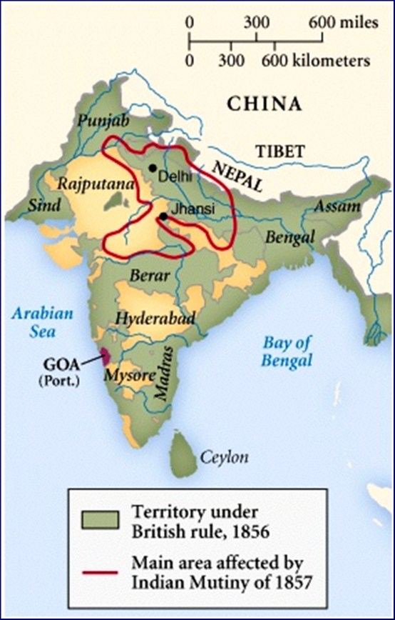
In the 1850’s the British East India Company was at the height of its power. By 1850, the Company had gained over 60 % of India. Their rule over India gave the East India Company a vast amount of wealth due to trade agreements and the acquisition of India’s natural resources. While in control of India, the British East India Company ruled without concern for cultural practices or religious concerns.
To help maintain order within the colony, the British East India Company hired Indian soldiers (known as Sepoys) to protect the interests of the Company. By the 1850’s there had been growing discontent amongst Indians who felt the British were unfairly taxing the native population as well as not redistributing within the colony more of the textile profits gained from India’s natural resources (particularly cotton manufacturing). The discontent became a rebellion in 1857 when Sepoys revolted against the British.
The reason for the Sepoy Rebellion was due to newly manufactured weapons given to the Sepoy soldiers. The weapons required soldiers to bite off the end of a powdered cartridge. The soldiers had discovered that the cartridges were either greased with pork fat or cow fat. This raised an issue amongst the soldiers. Due to religious practices, Muslim soldiers were forbidden to eat port fat while Hindu soldiers were forbidden from eating cow fat. The soldiers now refused to use the new cartridges. The British East India Company responded by sending the Sepoys home without pay. Due to this dismissal, the Sepoys revolted against the British.
The rebels would begin targeting British civilians and businesses that had moved to India. The British government would send troops to stop the rebellion. In their attempt to stop the rebellion the British soldiers would burn homes and villages and massacre native populations. The rebellion would take over a year to finally end.
In response, the British government effectively ended the rule of the British East India Company and placed India under the rule of the British government. The British would continue the practice of indirect rule and allow for more government participation and educational opportunity for the Indian population. While these reforms were improvements, British business interests were still of primary importance and British civilians still maintained a privileged status within India.
While unsuccessful, the Sepoy Rebellion marked a pivotal moment in the cause for Indian nationalism. The Rebellion also showed the difficulties of uniting India. Part of the failure of the Rebellion was due to religious differences between Hindu and Muslim populations within India.

- Why were Indians upset with British rule prior to 1857? _________________________________________
_______________________________________________________________________________________

- What caused the Sepoy Rebellion of 1857? ___________________________________________________
______________________________________________________________________________________________________________________________________________________________________________

- Who took political control of India following the Sepoy Rebellion? ________________________________
_______________________________________________________________________________________

- Identify two negative and two positive impacts which occurred as a result of the Sepoy Rebellion?
Positive

Negative

Document Analysis: Read the following documents and answer the following questions
Document #1 Joe Smith, British Historian
“How do your Indian people suffer? In fact, British rule of India brought improvements and health. We improved sanitation and the medical conditions of the people, built a school system similar to our own British system and brought all the blessings of European technology; factories, railroads, telephones, electricity, farm machinery!!! Why, the British introduced Christianity and democratic government to your people!!! Is this suffering?”
Does the speaker agree or disagree with imperialism? Why? _________________________________________
____________________________________________________________________________________________________________________________________________________________________________________

Document #2
As an Indian woman, I am happy about some of the changes the British have made however it was not their place to decide what to change and when to change it. They have ended some of the most long held cultural traditions and practices without thinking about how it will affect us, the people they day they are helping. What gives the British the right to end the Caste System that has kept out society orderly for thousands of years? Why is it their decision to end the practice of sati? Why do the British get to decide that a women should have the right to divorce her husband or own land? It is not their place to tell us how to live our lives in our own country.
Name two cultural practices the British ended in India? __________________________________________________________________________________________

Why is the woman angry about the end of these practices? _________________________________________
__________________________________________________________________________________________
Document #3 Mohandas Gandhi offers a complaint about imperialism
You English committed one supreme crime against my people. For a hundred years you have done everything for us. You have given us no responsibility for our government.
What is Gandhi’s criticism of imperialism? ______________________________________________________________________________________________________________________________________________________________________________________________________________________________________________________________________________

Summary: Based on the documents complete the chart on the positives and negatives of British imperialism in India.

Positive | Negative

