Dream Journal Assignment Name: Period:
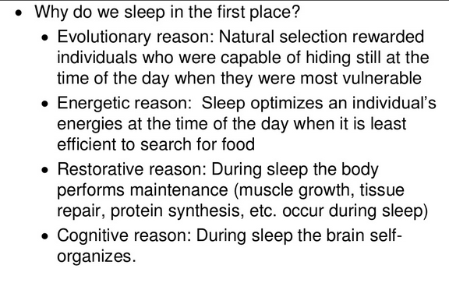
While science has figured out a lot about the purpose of sleeping (see right), we have a lot of ground to cover when it comes to understanding the purpose of dreaming. This project is designed to help you:
- become more aware of your dreams and how often you dream
- learn from your dreams
- learn more about the historical and contemporary theories and studies on dreaming
- become more curious about the field of Psychology in general
Procedure:
- Review of Dream Theories:
Read the dream theories outlined on the next page, and decide which theory or theories seem to make the most sense to you before starting to work on your journal.

- Dream Journal Logs:
- Keep a dream journal close to your bed and write down the dreams you recall immediately. Note: You may have more than one dream to report on when you wake up; most individuals dream between four and six times in one night.
- What should you record? First: everything as you remember them. Second: any editorializing or commentary. Do not worry about proper English. Write down any or all of the following:
    - Dialogue or any words
    - Number and types of people (friends, strangers, relatives)
    - Objects or items
    - Mood of the dream (happy, pleasant, neutral, exciting, scary, frightening, frustrating, etc.)
    - Settings, place, location
    - Relations to the dream and you (are you an observer, participant, seeing yourself as a player?, etc.)

- Dream Journal Interpretations & Research Paper Guidelines:
- Once you have at least 5 dreams in your journal, analyze them using online sources and the following questions as your guide.
      - How—if at all—could you categorize your dreams? Are they mostly bizarre? Mundane? Exciting? (Etc.)
      - Which dreams were most disturbing? Why? What do they mean to you?
      - What themes, symbols, etc., did you notice in your dreams? Were there common ideas, emotions, etc., running through your journal?
      - Were you able to control your dreams as you remembered more and more of them?
      - What did you learn about yourself after keeping a dream journal?
- Then write a 1-2 page research paper and a references page (2-3 pages in total): Use what we will learn from the PBS Dream Documentary, the dream theories mentioned in this document, class lectures, online dream dictionaries, and your own dreams to write a paper that clearly articulates your theory on dreams and clearly identifies aspects of your dreams.
  - This paper can be written using either one of the theories or a combination of theories, and it must also include one dream with fully interpreted meanings.
- Paragraphs 1-3: explain yourself and the theory/ theories that you have chosen
  - Who am I?.......What theory do I agree with & why?…..What is the purpose of dreaming?.....etc.
- Paragraphs 4-6: explain your dream, interoperate your dream, and reference at least one of the dream theories
  - What did I dream about?.....What does it mean to me?.....What does it mean after further research?....Why do I agree / disagree with the dream theory that I have chosen?
What You Turn In:
- Dream journal (5 dreams)
- Research Paper (2-3 pages in total including a reference page)

Dream Theories Summary
There are many dream theories that have been articulated by scientists and psychologists. What follows is a basic list of some of the more commonly-cited theories. You’ll need to be familiar with these theories to complete the Dream Journal Assignment.
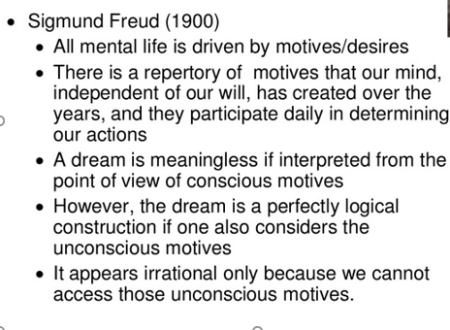
- Dream theory: Sigmund Freud
Dreams allow people to express unconscious wishes they find unacceptable in real life. Freud drew a distinction between the manifest content and the latent content of dreams. The manifest content is the plot of the dream: who’s in the dream, what happens, and so on. The latent content is the dream’s hidden meaning. According to Freud, the manifest content is a symbolic representation of the latent content. In other words, the plot acts as a disguise that masks the real meaning of the dream.
- Activation-Synthesis Theory
This theory proposes that neurons in the brain randomly activate during REM sleep. Dreams arise when the cortex of the brain tries to make meaning out of these random neural impulses. According to activation-synthesis theory, dreams are basically brain sparks. Much of the work outlined in the PBS video and supported by neuroscientists (biopsychologists) discounts this theory, but you could do some more research to provide evidentiary support for it.
- Problem-Solving Theory
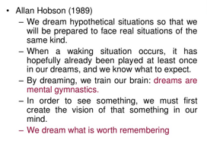
Some psychologists think that dreams express people’s most pressing concerns and might help to solve problems in day-to-day life. If someone has an important job interview coming up, for example, he may rehearse scenarios for the interview in his dreams. If someone has relationship difficulties with a significant other, his dreams may give him clues to help solve the problem.
A connected branch of this theory was articulated by the Finnish scholar from the PBS video, who argued that nightmares are practice sessions in which we refine our survival skills, and by M.I.T.’s Matt Wilson, who used his studies on rats to theorize about how dreams allow us to face challenges and test possibilities.
Psychologist Allan Hobson’s description (1989) puts it best
- Cognitive Development and Information Processing Theory
Some psychologists think that dreams help our brain mature by sifting, sorting, fixing, improving our memories and creativity, etc., to enable cognitive development. They consolidate memories, store information into memory, and process and organize information and stimuli from the day. Harvard’s Robert Stickgold from the PBS video highlighted this belief in his ski simulator studies, as did Sara Mednick (University of California, San Diego) and Deidre Barrett (Harvard). Revisit the PBS video analysis questions to see their contributions to this theory.

