Name: ________________________________________________ Period: ________
Document Based Question-Station Activity
Directions: You will be placed in a group of no more than 5 students. You and your group members will work together as you analyze the eight primary source documents in this station activity. At the end of the group analysis, each group member will answer a document based question in an essay format. You will use evidence from the documents to support your thesis. Use the analysis charts provided as you complete the station activity. The more thorough you are in your analysis, the more prepared you will be to write your essay. This essay will be a written assessment of the material you learn today.
Context/Background: Napoleon Bonaparte seized power in France by way of a coup d’ etat in 1799. His position as “consul for life” eventually gave way to emperor in 1804. This was an interesting transition as Napoleon thwarted many of the ideals of the French Revolution. The French Revolution intended to eliminate the concept of a monarchy, yet Napoleon seemed to reestablish it. Throughout Napoleon’s tenure, he attempted to not only secure political control of France, but also cultural control. He did so, in part, by censoring newspapers, books, plays, and sermons. He also commissioned paintings that placed him in a favorable light. Napoleon was very concerned about his public image and the image of France. Nothing could be produced that was contrary to the image he sought to create. In many ways, we can view Napoleon as a propagandist. He created propaganda, or one-sided information, that served a purpose. This was all done under the context of nationalism as Napoleon wanted nothing more than to build national unity.
Document Based Question: As you analyze the documents with your group, please refer back to the question below. This question should guide you throughout the documents because you should look for the ways that each document connects back to this question.
*Discuss the ways in which Napoleon Bonaparte attempted to control both his own image and the image of France through artistic propaganda and censorship of newspapers, plays, books and sermons.
Due Date: Both the station activity and the essay (written assessment) will be completed in class today.

Name: ________________________________________________ Period: ________
Student Document Analysis Worksheet
For each station, answer the following questions with as much detail as you can. The more detail you include, the more information you will have to write your document based essay.
Station 1  Letter | - Summarize what the author is saying.  - In what ways does the document connect to the question?  - What evidence in the document helps you know why it was written? What is the author’s purpose? Quote from the document.  - Is there any bias or authorial point of view that is interesting?
Station 2  Letter | - Summarize what the author is saying.  - In what ways does the document connect to the question?  - What evidence in the document helps you know why it was written? What is the author’s purpose? Quote from the document.  - Is there any bias or authorial point of view that is interesting?
Station 3  Painting | - What do you see in the painting that is interesting and connects to the question?  - Based on what you observe in the painting, is there anything you can infer? What is the artist’s purpose? What is the artist trying to convey to the viewer? Is the artist biased?
Station 4  Letter | - Summarize what the author is saying.  - In what ways does the document connect to the question?  - What evidence in the document helps you know why it was written? What is the author’s purpose? Quote from the document.  - Is there any bias or authorial point of view that is interesting?
Station 5  Letter | - Summarize what the author is saying.  - In what ways does the document connect to the question?  - What evidence in the document helps you know why it was written? What is the author’s purpose? Quote from the document.  - Is there any bias or authorial point of view that is interesting?
Station 6  Painting | - What do you see in the painting that is interesting and connects to the question?  - Based on what you observe in the painting, is there anything you can infer? What is the artist’s purpose? What is the artist trying to convey to the viewer? Is the artist biased?
Station 7  Letter | - Summarize what the author is saying.  - In what ways does the document connect to the question?  - What evidence in the document helps you know why it was written? What is the author’s purpose? Quote from the document.  - Is there any bias or authorial point of view that is interesting?
Station 8  Letter | - Summarize what the author is saying.  - In what ways does the document connect to the question?  - What evidence in the document helps you know why it was written? What is the author’s purpose? Quote from the document.  - Is there any bias or authorial point of view that is interesting?

FRENCH REVOLUTION WRTING RUBRIC
5  25-22 | • IDEAS AND EXPLANATIONS are insightful, thorough and supported by evidence.  • ORGANIZATION – uses appropriate transitions between and within paragraphs for consistently clear and smooth  • STYLE – is a pleasure to read – graceful, uncluttered, rich, vivid, and clear; shows sentence variety, and uses interesting and precise vocabulary.  • GRAMMAR AND MECHANICS – errors are rare, minor, or absent.
4  21-20 | • IDEAS AND EXPLANATIONS are reasonable, substantial, and supported by evidence.  • ORGANIZATION – is logical and appropriate for content, but not as smooth as a 4.  • STYLE – is clear, shows sentence variety, and uses interesting and precise vocabulary.  • GRAMMAR AND MECHANICS – errors are occasional.
3  19-18 | • IDEAS AND EXPLANATIONS are reasonable, substantial, and supported by evidence, but lacks detail of a “3” or “4.”  • ORGANIZATION – paragraphs are simplistic or idea relationships are sometimes unclear.  • STYLE – is functional but sentence variety and vocabulary are limited or paragraph is too wordy.  • GRAMMAR AND MECHANICS – errors are frequent.
2  17-15 | • IDEAS AND EXPLANATIONS didn’t have at least 3 solid examples. They are too simple, brief, vague, repetitious, hard to follow, irrelevant, weakly supported, and/or inadequate.  • ORGANIZATION – shows some minor skill but has major flaws  • STYLE – has major flaws e.g. simplistic, wordy, repetitious, monotonous, and often unclear.  • GRAMMAR AND MECHANICS – errors exist in almost every sentence and may interfere with meaning.
1  0-15 | • IDEAS AND EXPLANATIONS (didn’t have any solid examples). They are too simple, brief, vague, repetitious, hard to follow, irrelevant, weakly supported, and/or inadequate.  • ORGANIZATION – There is little to no organization  • STYLE – has major flaws e.g. simplistic, wordy, repetitious, monotonous, and unclear.  • GRAMMAR AND MECHANICS – errors exist in almost every sentence and may interfere with meaning.

Station 1
Document 1, Letter
Letter from Napoleon to Citizen Ripault, Napoleon’s Librarian, July 23, 1801

Citizen Ripault is to see that he is supplied every day with all the papers that come out, except the eleven political papers. He will read them carefully, make an abstract of everything they contain likely to influence public opinion, especially with regard to religion, philosophy, and political opinion. He will send me this abstract daily between five and six o’clock. Once every ten days he will send me an analysis of all the books or pamphlets which have appeared during that period, calling attention to any passages on moral questions. . . . He will take pains to procure copies of all the plays which are produced, and to analyze them for me, with observations of the same character as those mentioned above. This analysis must be made, at the least, within forty-eight hours of the production of the plays. He is to send me every first and sixth day, between five and six o’clock, a list of all the bills, 2 advertisements, etc. which deserve attention, as well as anything that has come to his knowledge, and anything that has been done or said in the various institutes, or important trials, that might be of interest from a political and moral point of view.

Station 2

Document 2, Letter

Letter from Napoleon to Portalis, September 19, 1805

Inform M. Robert, a priest at Bourges, of my displeasure at the extremely bad sermon on August 15.

Station 3

Document 3, Painting

Jacques-Louis David, Napoleon at the St. Bernard Pass, oil on canvas, 1801, Chateau de Malmaison, Rueil-Malmaison.

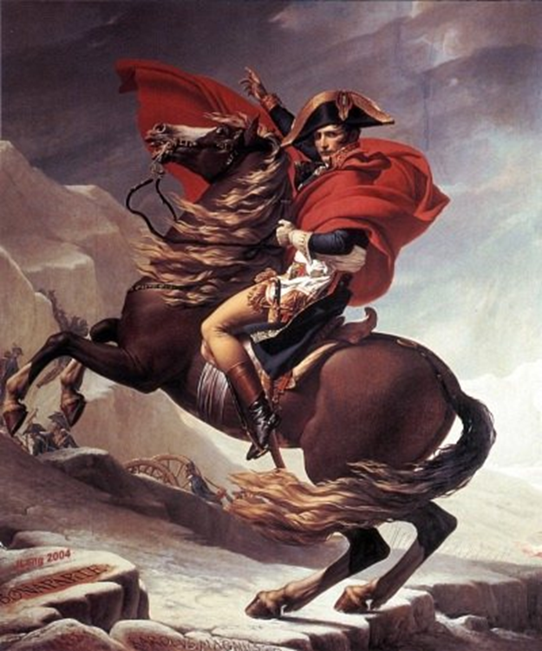

Station 4

Document 4, Letter

Letter From Napoleon to Fouché, June 1, 1805

I would like newspaper editors [to have] enough sense not to publish news harmful to the nation. The attention of the papers ought to be directed toward attacking England—English fashions, English customs, English literature, the English constitution. . . . Voltaire3 did us great harm by his constant essays in Anglomania. It seems to me that the success of the tragedy The Templars is turning attention to that incident in French history. That is good, but I don’t think we ought to allow plays on subjects of too recent a date. I see in one of the papers that there is talk of putting on a tragedy about Henry IV [d. 1610]. That period is not distant enough to rouse no passions. The stage needs a touch of antiquity: and I think that, without interfering with the theater too much, you ought to veto this particular play: but don’t make your intervention public.

Station 5

Document 5, Letter

Letter from Napoleon to Fouché, May 7, 1806

A fourth volume of Millot has just been published, containing all kinds of ridiculous nonsense and harmful to the glory of our arms. It is the height of indecency that such an ignoramus should write in the grand manner about contemporary events. Have the book suppressed.

Station 6

Document 6, Painting

Jean Auguste Dominique Ingres, Napoleon I on the Imperial Throne, oil on canvas, 1806, Musee de l’Armee, Hotel des Invalides, Paris.

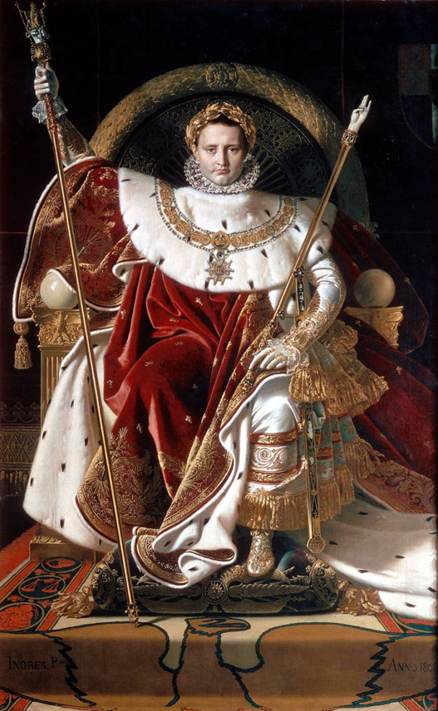

Station 7

Document 7, Letter

Jean-Antoine Chaptal, Minister of the Interior, 19th century

Napoleon did not care for the arts probably because nature had denied him the sensibility to appreciate their merit…Nevertheless…he always appeared to interest himself in the arts…He did this for political reasons in order to demonstrate his broadmindedness.

Station 8

Document 8, Letter

Lucien Bonaparte, Napoleon’s brother. Letter to David, Painter of the Government, 19th century.

You must understand my dear David that my brother Napoleon takes an interest only in pictures in which he counts for something. It is his weakness and he has no objections at all to being in the limelight.

