Name: _______________________________ Period: ___________________

UNIT 2 – THE CAUSES OF THE FRENCH REVOLUTION - DBQ

*This task is based on the accompanying documents. Some of these documents have been edited for the purpose of this task. This task is designed to test your ability to work with historic documents. As you analyze the documents, take into account both the source of the document and the author’s point of view

Historical Context
The French Revolution of 1789 had many long-range causes. Political, social, and economic conditions in France contributed to the discontent felt by many French people-especially those of the third estate. The ideas of the intellectuals of the Enlightenment brought new views of government and society. The American Revolution also influenced the coming of the French Revolution.

Directions
The following questions are based on the accompanying documents. As you analyze the documents, take into account both the source of the document and the author’s point of view.

Document 1: This excerpt is adapted from Travels in France by Arthur Young, who traveled through France from 1787 to 1789.

In the south of France there is a taille [tax on the land and its produce]. There is an injustice in levying the amount each person must pay. Lands held by the nobility are taxed very little.
Lands held by commoners are taxed heavily…
September 5, 1788: The poor people seem very poor indeed. The children are terribly ragged. June 10, 1789: The lack of bread is terrible. Stories arrive every moment from the provinces of riots and disturbances, and calling in the military, to preserve the peace of the markets….The price of bread has risen above people’s ability to pay. This causes great misery.
July 1789: ….I was joined by a poor woman who complained of the hard times. “The tailles and feudal dues [rents owed the lords] are crushing us,” she said.

Q: List three observations this traveler made about the life of the peasant in France between 1787 and 1789.

Document 2: This diagram illustrates the three estates in 1789 and the land each held during the Old Regime.

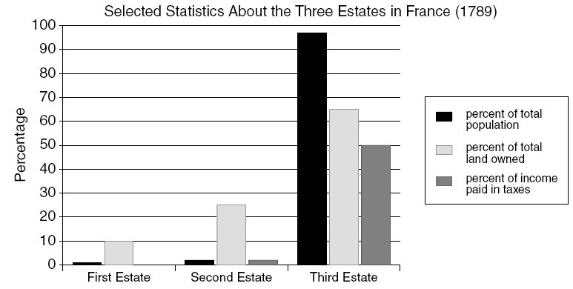

Q: What conclusions can you draw about the relationship between the percentage of the population in each estate and the percentage of land owned by that estate?

What unfair conditions existed in pre-revolutionary France?

Document 3: These excerpts from cahiers (lists of grievances about the king, taxing, and voting in the Estates General) brought to the Estates General..

That the king be forced to reform the abuses and tyranny of letter de cachet.
That every tax…. Be granted [by the Estates General] only for a limited time.
That the taille [a tax on land] be borne equally by all classes….
The meetings of the Estates General…. Shall be scheduled for definite times….
In order to assure the third estate the influence it deserves because of its numbers… its votes in the assembly should be taken by head…

Q: What three changes did the third estate demand be made in the French government?

Document 4: In The French Revolution, historian Albert Mathiez claims that leadership fell to the middle class with their knowledge of the ideas of the Enlightenment.

The Revolution had been accomplished in the minds of men long before it was translated into fact….
The middle class… was sensitive to their inferior legal position. The Revolution came from them-the middle class. The working classes were incapable of starting or controlling the Revolution. They were just beginning to learn to read.

Q: What was the result of the middle class’s knowledge of the ideas of the Enlightenment?

Document 5: Lord Acton suggested another point of view.

The condition of France alone did not bring about the overthrow of the monarchy… for the suffering of the people was not greater than they had been before. The ideas of the philosophs were not directly responsible for the outbreak…[but] the spark that changed thought into action was supplied by the Declaration of American Independence… The American example caused the Revolution to break out…

Q: What did Lord Acton believe caused the French revolution?

Document 6: Comte D’Antraigues as quoted in an excerpt form Citizens: A Chronicle of the French Revolution.

“The Third Estate is the People and the People is the foundation of the State; it is in fact the
State itself; the other estates are merely political categories while by the immutable
(unchangeable) laws of nature the People is everything. Everything should be subordinated (inferior) to it… It is in the People that all national power resides and for the People that all states exist.”

Q: What doe Comte D’Antraigues see as the rightful role of the Third Estate in France?

Document 7: The Political and Social System in France

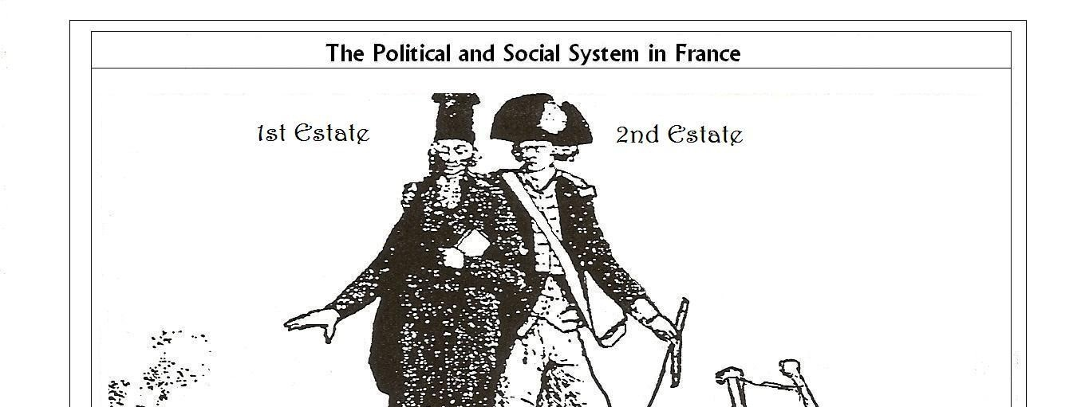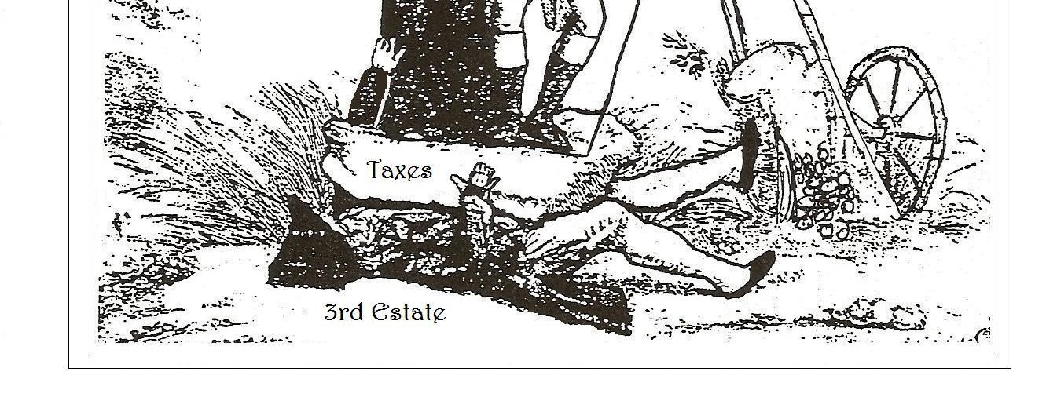
Q: What is the cartoonist saying about the relationship among the three estates in France?

SHORT RESPONSE QUESTION:
-In at least 2 paragraphs (5-7 sentences each) you will describe in historical detail the answer to the question below utilizing information from this DBQ, textbook, and class notes.
-What were the most important causes of the French Revolution? (Discuss three.)

