Careers: Welder, Cutter, Solderer or Brazer
By Bureau of Labor Statistics, adapted by Newsela staff
Grade Level 8
07/09/2017
Word Count 1039
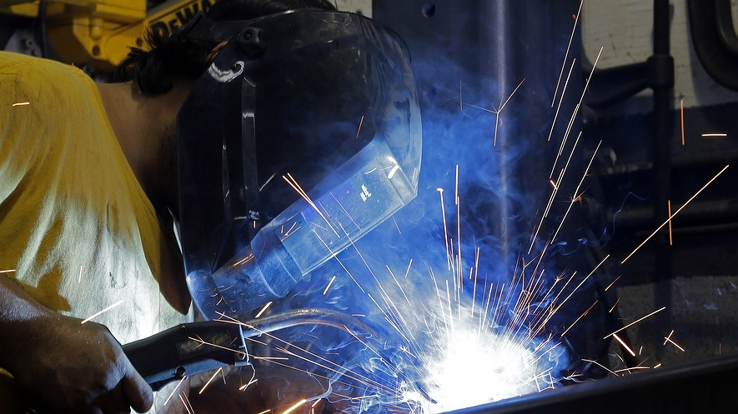In this September 14, 2015, photo, welder Gabriel Gonzalez welds a support beam at a local welding shop in Hialeah, Florida.
Welders, cutters, solderers and brazers work with metal. They use hand-held or remotely controlled equipment to join or cut metal parts. They also fill holes and seams of metal products.

Main Duties
Welders, cutters, solderers and brazers have a wide variety of responsibilities. They study blueprints and sketches of the metal objects they are helping to build, calculate the dimensions to be welded, and inspect the structures or materials that are to be welded. They ignite torches, start power supplies, and monitor the welding process to avoid overheating. They are often responsible for maintaining equipment and machinery.
Welding is the most common way of permanently joining metal parts. In this process, heat is applied to metal pieces, which melts and fuses them to form a permanent bond. Because of its strength, welding is used in shipbuilding, automobile manufacturing and repair, aerospace applications, and thousands of other manufacturing activities. Welding also is used to join steel beams in the construction of buildings, bridges, and other structures and to join pipes in pipelines, power plants, and refineries.
Welders work in a wide variety of industries, from car racing to manufacturing. The work that welders do and the equipment they use vary with the industry. There are more than 100 different processes that a welder can use. The type of weld normally is determined by the types of metals being joined and the conditions under which the welding is to take place.
Cutters use heat to cut and trim metal objects to specific dimensions. However, instead of joining metals, cutters use heat to cut and trim metal objects to specific dimensions. Cutters also take apart large objects, such as ships, railroad cars, automobiles, buildings and aircraft.
Solderers and brazers also use heat to join two or more metal objects together. Soldering and brazing are similar, except that the temperature used to melt the filler metal is lower in soldering. Soldering is often used to make electrical and electronic circuit boards, such as computer chips. Soldering workers tend to work with small pieces that must be positioned precisely. Brazing is commonly used to connect cast iron and thinner metals that the higher temperatures of welding would warp. Brazing also can be used to apply coatings to parts. These coatings can reduce wear and protect against corrosion.

Work Environment
Welders, cutters, solderers and brazers held about 397,900 jobs in 2014. Sixty percent of welders, cutters, solderers and brazers work in the manufacturing field. Another 6 percent work for specialty trade contractors; 5 percent work in repair and maintenance; and 4 percent work for merchant wholesalers.
Welding can involve working in uncomfortable conditions. Welders and cutters may work outdoors, often in poor weather, or indoors, sometimes in a confined area designed to contain sparks and glare. When working outdoors, they may work on a scaffold or platform high off the ground. In addition, they may have to lift heavy objects and work in awkward positions while bending, stooping, or standing to work overhead.

Injuries And Illnesses
Working with metal can be dangerous. Welders, cutters, solderers and brazers are often exposed to a number of hazards. These include very hot materials and intense light. They wear safety shoes, heat-resistant gloves, goggles, masks with protective lenses, and other equipment to prevent burns and eye injuries and to protect them from falling objects.
The Occupational Safety & Health Administration of the federal government requires that welders work in safely ventilated areas. Breathing gases and fine particles that can result from welding processes can be very harmful. Welding, cutting, soldering and brazing workers have a higher than average rate of injuries and illnesses. However, they can minimize injuries if they follow safety procedures.

How To Become A Welder, Cutter, Solderer Or Brazer
A high school diploma or equivalent combined with technical and on-the-job training is typically required to become a welder, cutter, solderer or brazer. High school technical education courses, vocational-technical institutes, and community colleges are places where one can learn to weld. Private welding, soldering and brazing schools offer formal technical training. In addition, the U.S. armed forces operate welding and soldering schools.
Welders may take courses in blueprint reading, shop mathematics, mechanical drawing, physics, chemistry and metallurgy. An understanding of electricity also is helpful. Knowledge of computers is gaining importance as well.
Many employers are willing to hire inexperienced entry-level workers and train them on the job. But others prefer to hire workers who have been through training programs. Even entry-level workers with formal technical training still receive several months of on-the-job training. Some employers pay the cost of training and testing for employees.

Important Qualities
Welders, cutters, solderers and brazers perform precision work, often with straight edges and minimal flaws. The ability to see details and characteristics of the joint and detect changes in molten metal flows requires good eyesight and attention to detail.
Welders, cutters, solderers and brazers must have a steady hand to hold a torch in one place. The ability to endure long periods of standing or repetitious movements is important for welders, cutters, solderers and brazers. Since they often must lift heavy pieces of metal and move welding or cutting equipment, and sometimes bend, stoop, or reach while working, they should be strong and in good physical condition.

Pay
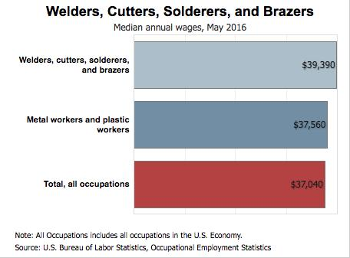Click to expandThe median annual wage for welders, cutters, solderers and brazers was $39,390 in May 2016. The median wage is the wage at which half the workers in an occupation earned more than that amount and half earned less. Wages for welders, cutters, solderers, and brazers vary with the worker’s experience and skill level, the industry, and the size of the company.

Job Outlook
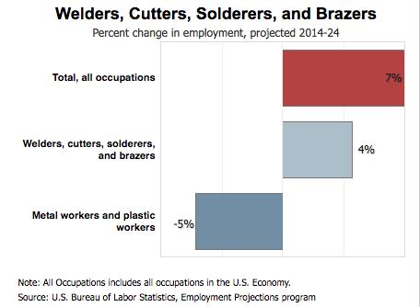Note: All Occupations includes all occupations in the U.S. Economy. [Click to expand]
Employment of welders, cutters, solderers and brazers is projected to grow 4 percent from 2014 to 2024, slower than the average for all occupations. Employment growth reflects the need for welders in manufacturing because of the importance and versatility of welding as a manufacturing process.
Welders, cutters, solderers and brazers will be needed in the future to help rebuild bridges, highways, and buildings. The construction of new power generation facilities and, specifically, pipelines transporting natural gas and oil will also result in new jobs.
Writing Prompt: Would you consider a career in this field? Why or why not? Use details from the article and from your personal life to explain your answer.

