Careers: Technical Writer
By U.S. Bureau of Labor Statistics, adapted by Newsela staff
Grade Level 9
07/23/2017
Word Count 1052
Andrew Goldberg, technical writer at iFixit, photographs a teardown of an iphone at their San Luis Obispo, California, office on November 20, 2012, where the company illustrates how to repair your electronics yourself through online photographs and videos. iFixit composes and posts the repair manuals and sells tools, parts and upgrades for many electronic devices and most Apple products. (Al Seib/Los Angeles Times/MCT)
Technical writers are also called technicalcommunicators. They prepare instruction manuals, how-to guides, journal articles and other supporting documents to communicate complex and technical information more easily. They also develop, gather and distribute technical information through an organization’s communications channels.

Duties
Technical writers typically do the following:
• Determine the needs of users of technical documentation
• Study product samples and talk with product designers and developers
• Work with technical staff to make products easier to use and thus require fewer instructions
• Organize and write supporting content for products
• Use photographs, drawings, diagrams, presentations and charts that increase users’ understanding
• Select appropriate medium for message or audience, such as manuals or online videos
• Standardize content across platforms and media
• Gather user feedback to update and improve content
• Revise content as new issues arise
Technical writers create paper-based and digital operating instructions, how-to manuals, assembly instructions and “frequently asked questions” pages. These documents help technical support staff, consumers and other users within a company or an industry. After a product is released, technical writers also may work with customer-service managers to improve the end-user experience through product design changes.
Technical writers often work with computer hardware engineers, scientists, computer support specialists and software developers. They work together to manage the flow of information among project work-groups during development and testing. Therefore, technical writers must be able to understand complex information. Then they must communicate the information to people with many different professional backgrounds.
Applying their knowledge of the user of the product, technical writers may serve as part of a team. These teams conduct usability studies to help improve the design of a product that is in its earliest stages. Technical writers may conduct research on their topics through personal observation, library and Internet research and discussions with technical specialists.
Technical writers are also responsible for managing the consistency of technical content and its use across business departments. This includes product development, manufacturing, marketing and customer relations.
Some technical writers help write grant proposals for research scientists and institutions.
Increasingly, technical information is being delivered online and through social media. Technical writers are using the interactive technologies of the Web and social media to blend text, graphics, multidimensional images, sound and video.

Work Environment
Technical writers held about 52,000 jobs in 2014. The largest employers of technical writers were as follows:
Professional, scientific and technical services: 38 percent
Manufacturing: 15 percent
Information: 12 percent
Administrative and support services: 8 percent
Most technical writers work in offices. They routinely work with engineers and other technology experts to manage the flow of information throughout an organization. Technical writing jobs are usually concentrated in locations, such as California and Texas, with information technology or scientific and technical research companies.

Work Schedules
Technical writers may be expected to work evenings and weekends to coordinate with those in other time zones or to meet deadlines. Most work full time.

How To Become A Technical Writer
A college degree is usually required for a position as a technical writer. Employers generally prefer candidates with a bachelor’s degree in journalism, English or communications. Many technical writing jobs require both a degree and knowledge in a specialized field, such as engineering, computer science or medicine. Web design experience also is helpful because of the growing use of online technical documentation.

Work Experience In A Related Occupation
Some technical writers begin their careers as specialists or research assistants in a technical field. They eventually develop technical communication skills and assume primary responsibilities for technical writing. Many technical writers need short-term on-the-job training to adapt to a different style of writing.

Licenses, Certifications And Registrations
Some associations, including the Society for Technical Communication, offer certification for technical writers. In addition, the American Medical Writers Association offers extensive continuing education programs and certificates in medical writing. Although not necessary, certification can demonstrate competence and professionalism, making candidates more attractive to employers.

Advancement
Prospects for advancement generally include working on more complex projects and leading or training junior staff. Some technical writers become self-employed and produce work on a freelance basis.

Important Qualities
Communication skills. Technical writers must be able to take complex, technical information and translate it for people whom they work with and consumers who do not have technical backgrounds.
Detail oriented. Technical writers create detailed instructions for others to follow. As a result, they must be detailed and precise at every step so that the instructions can be useful.
Imagination. Technical writers must be able to think about a procedure or product in the way a person without technical experience would think about it.
Teamwork. Technical writers must be able to work well with others. They are almost always part of a team: with other writers; with designers, editors and illustrators; and with the technical people whose information they are explaining.
Technical skills. Technical writers must be able to understand highly complex information. Many technical writers need a background in engineering or computer science in order to do this.
Writing skills. Technical communicators must have excellent writing skills to be able to explain technical information clearly.

Pay
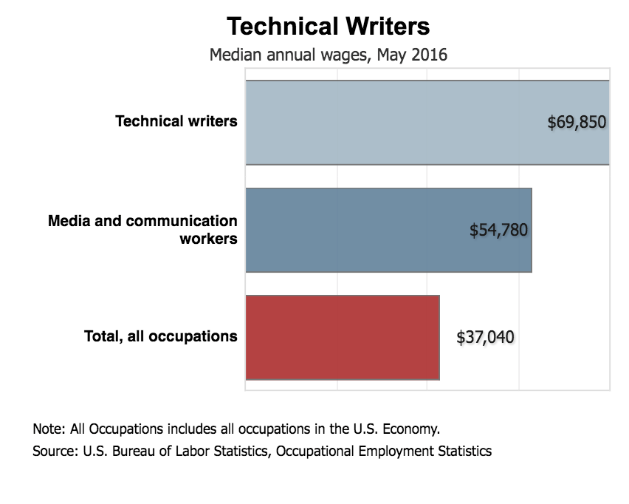Graph: Bureau of Labor Statistics. [click to enlarge]
The median annual wage for technical writers was $69,850 in May 2016. The median wage is the wage at which half the workers in an occupation earned more than that amount and half earned less. The lowest 10 percent earned less than $41,700, and the highest 10 percent earned more than $111,260.
In May 2016, the median annual wages for technical writers in the top industries in which they worked were as follows:
Professional, scientific and technical services: $71,910
Information: $69,730
Administrative and support services: $69,580
Manufacturing: $68,900

Job Outlook
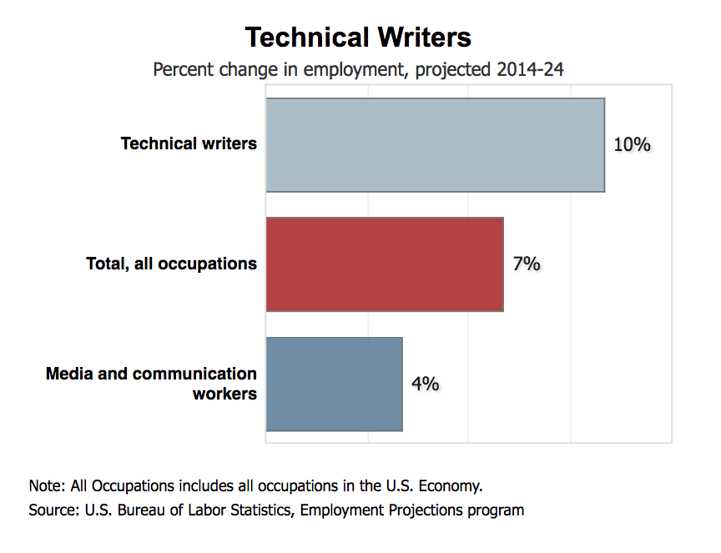Graph: Bureau of Labor Statistics. [click to enlarge]
Employment of technical writers is projected to grow 10 percent from 2014 to 2024. This is faster than the average for all occupations.
Scientific and technical products and growth in Web-based product support is expected to expand. This expansion will drive employment demand for technical writers. Growth and change in the high-technology and electronics industries will result in a greater need for those who can write instruction manuals and communicate information clearly to users.
The need to replace workers who retire over the coming decade will result in some job openings. However, there will be competition among freelance technical writers.
Writing Prompt: What role does this career play in society and the economy? Write two paragraphs using details from the article.

