Careers: Police Officer or Detective
By U.S. Bureau of Labor Statistics, adapted by Newsela staff
Grade Level 8
07/10/2017
Word Count 1196
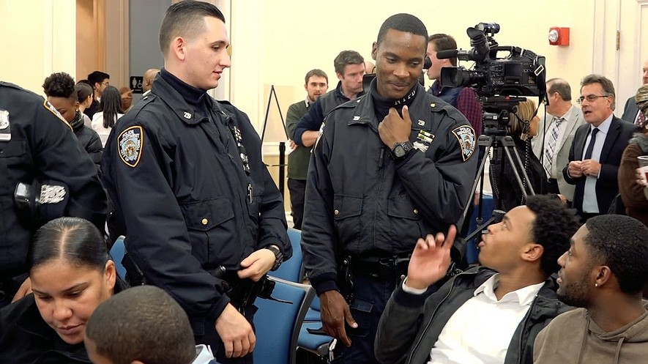Police officers in Brooklyn, New York.Police officers, detectives and criminal investigators typically enforce laws and respond to emergency and nonemergency calls.
Police officers protect lives and property. They pursue and apprehend people who break the law. They warn, cite or arrest them. Most police officers patrol a specific area and investigate suspicious activity. They also respond to calls, issue traffic tickets and give first aid to accident victims.
Detectives investigate crimes by gathering facts and collecting evidence.
Most officers and detectives carry radios, handcuffs and guns.

State And Local Law Enforcement
Uniformed police officers wear uniforms that allow the public to easily recognize them as police officers. They have regular patrols and also respond to emergency and nonemergency calls. During patrols, officers look for any signs of criminal activity and may conduct searches and arrest suspected criminals.
Some police officers work only on a specific type of crime, such as illegal drugs. Officers, especially those working in large departments, may work in special units, such as horseback, motorcycle, canine corps, and special weapons and tactics (SWAT).
State police officers, sometimes called state troopers or highway patrol officers, have many of the same duties as other police officers. They may spend more time enforcing traffic laws and issuing traffic tickets. State police officers can work anywhere in the state and are frequently called on to help other law enforcement agencies, especially those in rural areas or small towns.
Transit and railroad police patrol railroad yards and train and bus stations. They protect property, employees, and passengers from crimes such as thefts and robberies.
Sheriffs and deputy sheriffs enforce the law on the county level. Sheriffs are usually elected by the public and do the same work as a local or county police chief. Some sheriffs’ departments do the same work as officers in urban police departments, while others mainly operate county jails and provide services in local courts.
Detectives and criminal investigators gather facts and collect evidence for criminal cases. They conduct interviews, examine records, observe the activities of suspects, and participate in raids and arrests. Detectives usually specialize in investigating one type of crime, such as homicide or fraud.
Fish and game wardens enforce fishing, hunting and boating laws. They patrol fishing and hunting areas, conduct search and rescue operations, and investigate complaints and accidents.

Federal Law Enforcement
Federal Bureau of Investigation (FBI) agents are the federal government's principal investigators. They enforce more than 200 categories of federal crime and conduct national security investigations. Drug Enforcement Administration (DEA) agents enforce laws and regulations relating to illegal drugs. United States Secret Service uniformed officers protect the president, the vice president, their immediate families and other public officials. Federal Air Marshals protect U.S. aircraft, passengers and crews. U.S. Border Patrol agents protect the U.S. land and sea boundaries.

Work Environment
In 2014, there were about 806,400 police officers and detectives.
Police and detective work can be physically demanding and dangerous. They regularly work at crime and accident scenes and deal with death and suffering. Although a career in law enforcement may be stressful, many officers find it rewarding to help members of their communities.

Injuries And Illnesses
Police and sheriff’s patrol officers have one of the highest rates of injuries and illnesses of all occupations. They may be hurt during conflicts with criminals and motor-vehicle chases.

Work Schedules
Uniformed officers, detectives, agents and wardens usually work full time, and paid overtime is common. They may work nights and weekends because the public must be protected at all times.

Education
Police and detective applicants must have at least a high school diploma or equivalent, although many departments require some college classes or a college degree. Many colleges and universities offer programs in law enforcement and criminal justice. Knowledge of a foreign language is helpful in many federal agencies and areas.
People applying for federal jobs with the U.S. Fish & Wildlife Service typically need a college degree. Those applying to a state’s natural resources department often need a high school diploma or some college classes in biology or natural resources management.
State and local agencies encourage applicants to continue their education after high school by taking courses and training related to law enforcement.

Training
Police candidates usually attend a training academy before becoming an officer. They learn about state and local laws and constitutional law, civil rights and police ethics. Recruits also receive on-the-job training in areas such as patrol, traffic control, firearm use, self-defense, first aid and emergency response.

Work Experience In A Related Occupation
Detectives normally begin their careers as police officers.
Typically, FBI special agent applicants must have at least three years of professional work experience in areas ranging from computer science to accounting.
Military or police experience may be considered helpful.

Advancement
Promotions usually are made according to a candidate's position on a list, which is determined by scores on written tests and on-the-job performance. In large departments, officers may be promoted to detective or specialize in one type of police work, such as working with children.

Important Qualities
Police, detectives, and fish and game wardens must have good communication skills.They must be able to speak with people when gathering facts about a crime and to express details about a given incident in writing.
They also must be empathetic. They need to understand the perspectives of a wide variety of people and have a willingness to help the public.
Police and detectives must have good judgment and must be able to solve different kinds of problems quickly.
Police officers must have good leadership skills, because the public looks to them for help in emergencies.
Officers, detectives, and fish and game wardens must be perceptive. They must be able to anticipate a person’s reaction and understand why people act a certain way.
Officers and detectives must be in good physical shape and must be strong enough to catch criminals.

Pay
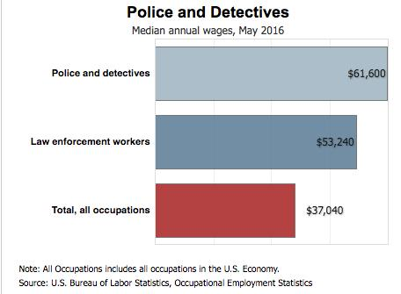What police get paid[Click to enlarge]
The median annual wage for police and detectives was $61,600 in May 2016. The median wage is the wage at which half the workers in an occupation earned more than that amount and half earned less. The lowest 10 percent earned less than $34,970, and the highest 10 percent earned more than $102,750.
Median annual wages for police and detectives in May 2016 were as follows:
Detectives and criminal investigators were paid the best at $78,120. Transit and railroad police came next at $66,610. Police and sheriff’s patrol officers received $59,680, and fish and game wardens earned a median of $51,730.
Uniformed officers, detectives, agents and wardens usually work full time. Paid overtime is common.

Job Outlook
Employment of police and detectives is expected to grow 4 percent from 2014 to 2024. That is a lower rate than other jobs.
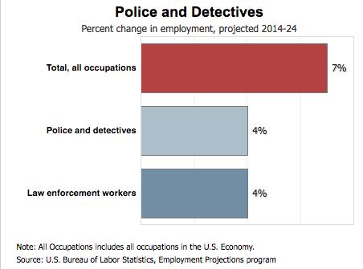The growth of police jobs [Click to enlarge]There will be a demand for more officers. However, new jobs will depend on what part of the country it is and how much money local authorities have.

Job Prospects
Overall job prospects are expected to be good. Applicants with a bachelor's degree and law enforcement or military experience should have the best job opportunities. Investigative experience is especially helpful, and so is the ability to speak another language.
Writing Prompt: What role does this career play in society and the economy? Write two paragraphs using details from the article.

