Careers: Construction Manager
By U.S. Bureau of Labor Statistics, adapted by Newsela staff
Grade Level 9
07/12/2017
Word Count 1544
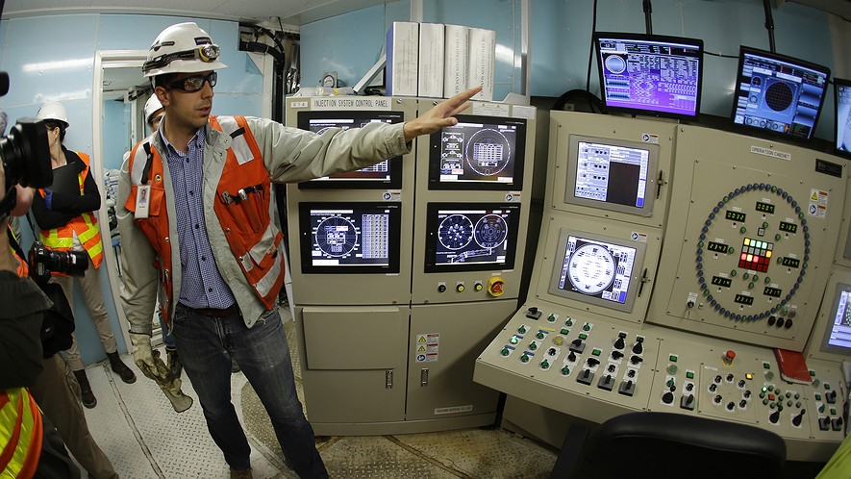Juan Garnero, a construction manager with Seattle Tunnel Partners, gives a tour of the control room of "Bertha," the massive tunnel boring machine that is expected to spend the next 14 months drilling a two-mile tunnel to replace the 60-year-old Alaskan Way Viaduct, Saturday, July 20, 2013 in Seattle. (AP Photo/Ted S. Warren)Construction managers plan and supervise construction projects from start to finish.

Duties
Construction managers, often called general contractors or project managers, coordinate and supervise many types of projects. These include the building of all types of structures, as well as roads, memorials and bridges. Either a general contractor or a construction manager will oversee the construction phase of a project. However, a construction manager may also talk with the customer during the design phase to help tighten up construction plans and control costs.
Construction managers oversee specialized contractors and other workers. They organize all the stages of construction to meet the needs of the design, and that projects are completed on time and within budget.
Construction managers work closely with other building specialists, such as architects, civil engineers, and trade workers, including stonemasons, electricians and carpenters. Specialists may work in everything from structural steel and painting to landscaping, paving roads, and excavating sites.
Depending on the project, construction managers may interact with lawyers and local government officials. For example, when working on city-owned property or municipal buildings, managers sometimes talk with city inspectors to ensure that all regulations are met.
Some projects may be too large to be managed by one person, such as large office buildings. In that case, a construction manager hires other construction managers to be in charge of different aspects of the project. For example, each construction manager would oversee a specific phase of the project, such as structural foundation, plumbing, or electrical work, and hire other contractors to complete it. The top-level construction manager would then coordinate with the other construction managers.
To maximize efficiency and productivity, construction managers often estimate costs, using special software to plan how to divide up time and money for projects.

Work Environment
Construction managers held about 373,200 U.S. jobs in 2014.
About 4 in 10 construction managers were self-employed in 2014. They work for themselves, not for another company.
Many construction managers have a main office, but they spend most of their time working out of an office at the construction site. There, they monitor the project and make daily decisions about construction activities. For those managing multiple projects, frequent travel between sites is required.

Work Schedules
Most construction managers work full time. However, they need to meet deadlines. Responding to delays and emergencies often requires construction managers to work many hours. Many managers may also be on call to work any of the 24 hours of a day.

How To Become A Construction Manager
New construction managers are typically hired as assistants and work under the guidance of an experienced manager. Large construction firms increasingly prefer candidates with both construction experience and a bachelor’s degree in a construction-related field. Some individuals with a high school diploma and many years of experience in a construction trade may be hired as construction managers. However, these individuals are typically qualified to become self-employed general contractors.

Education
It is becoming increasingly important for construction managers to have a bachelor’s degree in construction science, construction management, architecture, or engineering. As construction processes become more complex, employers want managers to have more specialized education.
More than 100 colleges and universities offer bachelor’s degree programs in construction science, building science, or construction engineering. These programs include courses in project control and management, design, construction methods and materials, cost estimation, building codes and standards, and contract administration. Courses in mathematics and statistics are also relevant.
More than 50 two-year colleges offer construction management or construction technology programs. An associate’s degree combined with work experience is typical for managers who supervise smaller projects.
A few universities offer master’s degree programs in construction management.
Those with a high school diploma and several years of relevant work experience may qualify to become a construction manager, although most are qualified to become self-employed general contractors.

Training
New construction managers are typically hired as assistants and work under the guidance of an experienced manager. This training period may last several months to several years, depending on the firm.

Work Experience
If the typical education is not obtained, practical construction experience is important for job seekers, because it reduces the need for initial on-the-job training. Internships, cooperative education programs, and previous work in the construction industry can provide that experience. Some construction managers become qualified solely through extensive construction experience, spending many years in carpentry, masonry, or other construction specialties.

Licenses, Certifications And Registrations
Although not required, certification is becoming increasingly important for construction managers. Certification is valuable because it can demonstrate knowledge and experience.
The Construction Management Association of America awards the Certified Construction Manager (CCM) title to workers who have the required experience and who pass a technical exam. It is recommended that applicants for this certification complete a self-study course. It covers the professional role of a construction manager, legal issues, and other topics related to construction management.
The American Institute of Constructors certifies people as Associate Constructor (AC) or Certified Professional Constructor (CPC). They have separate requirements and other construction exams.
Some states require licenses for construction managers. For more information, contact your state licensing board.

Important Qualities
Analytical skills. Most managers plan a project strategy, handle unexpected delays, and solve problems that arise over the course of the project. Many managers use software to determine costs and the materials and time required to complete projects.
Business skills. Construction managers address budget matters and coordinate and supervise workers. Choosing competent staff and establishing good working relationships with them is critical.
Customer-service skills. Construction managers are in constant contact with owners, inspectors, and the public. They must form good relationships with these people and ensure their needs are met.
Decision-making skills. Construction managers choose workers for specific tasks and jobs. Often, these choices must be made quickly to meet deadlines and budgets.
Self-motivation. Self-employed construction managers generate their business opportunities and must be proactive in finding new clients. They must also learn how to do home improvement skills they may not know, such as installing mosaic glass tiles, sanding wood floors and insulating homes.
Leadership skills. Managers must smartly assign tasks to construction workers, subcontractors, and other managers.
Speaking skills. Managers must give clear orders, explain complex information to construction workers and clients, and discuss technical details with other building specialists, such as architects. Self-employed construction managers must get their own projects, so the need to sell their services to potential clients is critical.
Technical skills. Managers must know construction methods and technologies, and must be able to understand contracts and technical drawings.
Time-management skills. Construction managers must meet deadlines. They ensure that construction phases are completed on time so that the next phase can begin as scheduled. For instance, a building’s foundation cannot be constructed until the land is completely dug up.
Writing skills. Construction managers must write proposals, plans, and budgets, as well as document the progress of the work for clients and others involved in the building process.

Pay
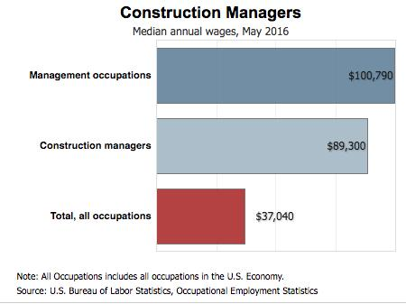What construction workers get paid [Click to enlarge]
The median annual wage for construction managers was $89,300 in May 2016. The median wage is the wage at which half the workers in an occupation earned more than that amount and half earned less. The lowest 10 percent earned less than $53,740, and the highest 10 percent earned more than $158,330.
In May 2016, the median annual wages for construction managers in the top industries in which they worked were as follows:
Heavy and civil engineering construction, like for roads and bridges – $93,980
Nonresidential building construction, like office buildings – $91,030
Specialty trade contractors – $84,270
Residential building construction, like homes – $81,450
Some salaried construction managers may also earn bonuses and overtime pay. For self-employed contractors, their earnings are highly dependent on the amount of business they generate.

Job Outlook
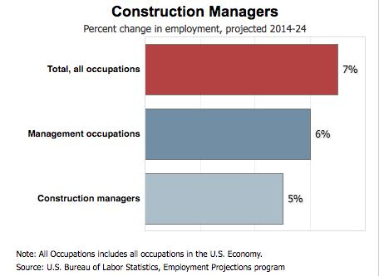The increase in construction jobs [Click to expand]
Employment of construction managers is projected to grow 5 percent from 2014 to 2024, about as fast as the average for all occupations.
Construction managers will be needed as overall construction activity expands. Population and business growth will result in the construction of new residences, office buildings, retail stores, hospitals, schools, restaurants, and other structures over the coming decade. Also, there's a need for construction managers to improve portions of the national infrastructure, such as roads, bridges and sewer pipe systems.
Many buildings need to be retrofitted to make them use energy better. This should create jobs for general contractors, who are more likely to manage the upgrading of buildings than oversee new large-scale construction projects.
Firms are increasingly focusing on hiring construction managers as building technology gets more complex.

Job Prospects
Job opportunities for qualified construction managers are expected to be good. Specifically, those with a bachelor’s degree in construction science, construction management, or civil engineering, coupled with construction experience, will have the best job prospects.
Although employment growth will provide many new jobs, many construction managers are expected to retire over the next decade. This should result in additional job openings.
Employment of construction managers, like that of many other construction workers, depends on how the economy is doing. When the overall economy is suffering, workers in the construction industry may experience periods of unemployment as construction falls. On the other hand, more building activity may produce more job opportunities for construction managers.
Writing Prompt: What role does this career play in society and the economy? Write two paragraphs using details from the article.

