Careers: Chef or Head Cook
By U.S. Bureau of Labor Statistics, adapted by Newsela staff
Grade Level 8
07/11/2017
Word Count 1058
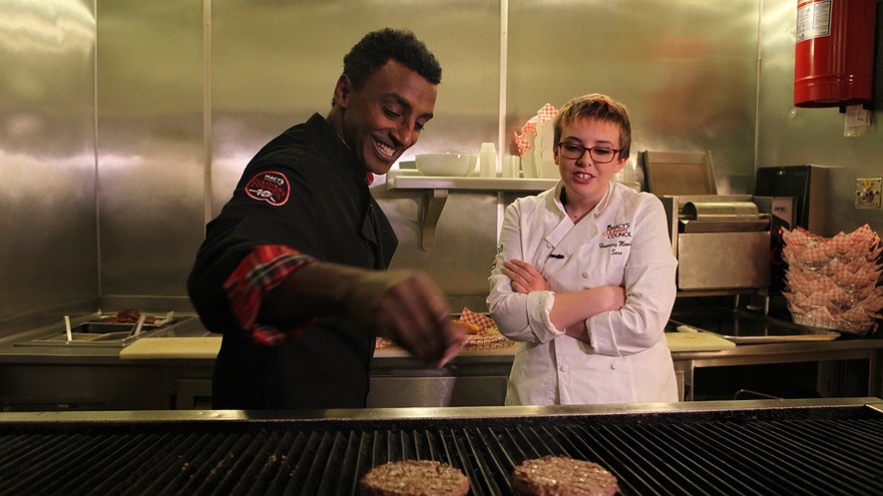Marcus Samuelsson, head chef at Red Rooster and Aquavit in New York, teaches during “Wishes Across America” on Macy's National Believe Day, with Make-A-Wish child Sara, 17, in Chicago, Illinois, December 6, 2013.

Chefs and head cooks oversee the daily food preparation at restaurants and other places where food is served. They direct kitchen staff and handle any food-related concerns.

Duties
Chefs and head cooks typically do the following:
• Check the freshness of food and ingredients.
• Supervise and coordinate activities of cooks and other food-preparation workers.
• Develop recipes and determine how to present food.
• Plan menus and ensure the quality of meals.
• Inspect supplies, equipment and work areas for cleanliness and usefulness.
• Hire, train and supervise cooks and other food preparation workers.
• Order and maintain an inventory of food and supplies.
• Monitor cleanliness practices and follow kitchen safety standards.
Chefs and head cooks use a variety of kitchen and cooking equipment, including step-in coolers, high-quality knives, meat slicers and grinders. They also have access to large quantities of meats, spices and produce. Some chefs use software to help them with scheduling and purchasing food and supplies.
Chefs who run their own restaurant or catering business are often busy with kitchen and office work. Some chefs use social media to promote their business by advertising new menu items or addressing customer reviews.
Here are examples of types of chefs and head cooks:
Executive chefs, head cooks and chefs de cuisine are responsible primarily for overseeing the operation of a kitchen. They coordinate the work of sous chefs, who are second in command, and other cooks, who prepare most of the meals. Executive chefs also have many duties beyond the kitchen. They design the menu, review food and beverage purchases, and often train cooks and other food preparation workers. Some executive chefs primarily handle administrative tasks and might spend less time in the kitchen.
Sous chefs supervise the restaurant’s other cooks, prepare meals and report to the head chefs. In the absence of the head chef, sous chefs run the kitchen.
Private household chefs typically work full time for one client. This might be a corporate executive, university president, diplomat or others who regularly entertains as part of his or her job.

Work Environment
Chefs and head cooks held about 127,500 jobs in 2014. The largest employers of chefs and head cooks were as follows:
Restaurants and other eating places: 52 percent
Special food services: 11 percent
Traveler accommodations: 10 percent
Chefs and head cooks work in restaurants, hotels, private households and other food service facilities, all of which must be kept clean and sanitary.
Chefs and head cooks usually stand for long periods and work in a fast-paced environment.
About 1 in 20 chefs and head cooks were self-employed in 2014. Running a restaurant or catering business can be more stressful. For example, they often spend many hours managing the business to ensure that bills and salaries are paid and that the business is profitable.

Injuries And Illnesses
Kitchens are usually crowded and filled with dangerous objects and areas, such as hot ovens and slippery floors. As a result, chefs and head cooks have a higher rate of injuries and illnesses than the national average. The most common hazards include slips, falls, cuts and burns.

Work Schedules
Most chefs and head cooks work full time, including early mornings, late evenings, weekends and holidays. So many chefs usually work more than 40 hours a week.

How To Become A Chef Or Head Cook
Most chefs and head cooks learn their skills through work experience. Others receive training at a community college, technical school, culinary arts school or four-year college.

Education
Although education after high school is not required for chefs and head cooks, many attend programs at community colleges, technical schools, culinary arts schools and four-year colleges.
Students in culinary programs spend most of their time practicing their cooking skills and learning about menu planning, food sanitation procedures, and purchasing and inventory methods.

Work Experience In A Related Occupation
Most chefs and head cooks start working in other positions to learn from other chefs. Many work for years before gaining enough experience to be promoted to chef or head cook.

Training
Apprenticeships are training programs that generally last two years and combine instructions with on-the-job training.
The American Culinary Federation accredits more than 200 academic training programs at post-secondary schools and sponsors apprenticeships around the country.

Licenses, Certifications, Registrations
Although not required, certification can show competence and lead to advancement and higher pay. Certification standards are based primarily on work-related experience and formal training.

Important Qualities
Business skills: Chefs who run their own restaurant need to know how to budget for supplies, set prices and manage workers so that the restaurant is profitable.
Communication skills: Chefs must communicate their instructions clearly so orders are prepared correctly.
Creativity: Chefs need to be creative to develop and prepare interesting and innovative meals.
Leadership skills: Chefs must motivate kitchen staff and develop constructive and cooperative working relationships with them.
Stamina: Chefs often work long shifts and sometimes spend entire days on their feet.
Time management: Chefs must ensure that meals are prepared correctly and that customers are served on time.

Pay
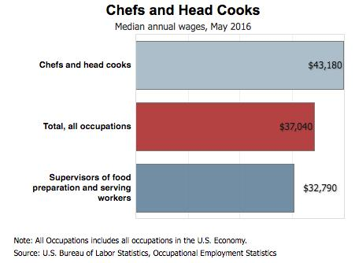What chefs get paid [Click to expand]
The median annual wage for chefs and head cooks was $43,180 in May 2016. The median wage is the amount at which half the workers in an occupation earned more and half earned less.
The lowest 10 percent earned less than $23,630, and the highest 10 percent earned more than $76,280.
The level of pay for chefs and head cooks varies greatly by region and employer, and pay is usually highest in upscale restaurants and hotels.
About 1 in 20 chefs and head cooks were self-employed in 2014.

Job Outlook
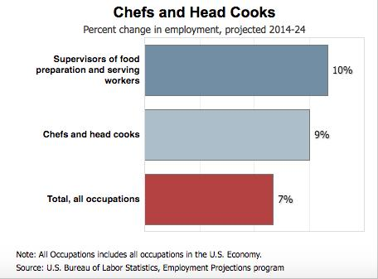The growth of chef jobs [Click to expand]
Employment of chefs and head cooks is projected to grow 9 percent between 2014 and 2024, which is faster than the average for all occupations.
Population and income growth means more restaurants and other dining places are expected to open.
Consumers also are continuing to demand healthier meals made from scratch. To ensure high-quality dishes, establishments are increasingly hiring experienced chefs to oversee food preparation.

Job Prospects
Job opportunities should be best for chefs and head cooks with several years of work experience.
There will be strong competition for jobs at upscale restaurants, hotels and casinos, where the pay is typically highest. Workers with a combination of business skills, work experience and creativity should have the best job prospects.

