Careers: Bookkeeping, Accounting or Auditing Clerk
By Bureau of Labor Statistics, adapted by Newsela staff
Grade Level 8
07/12/2017
Word Count 1121
Tori Stinson (left) at Meadowbrook Insurance Company checks a client's paperwork in 2004 in Southfield, Michigan, and right, the TurboTax online tax computer program is displayed on a computer in Palo Alto, California, in 2008. The number of bookkeeping, accounting and auditing clerks fell from 1.7 million to 1.3 million in the United States in 10 years through 2010. (Photos: AP)
More organizations are computerizing their financial records. As a result, many bookkeeping, accounting and auditing clerks need to use specialized accounting software, spreadsheets and databases. Bookkeeping, accounting and auditing clerks produce financial records for organizations. They record financial transactions, update statements and check financial records for accuracy. If the clerks do well, and get the right education, they might be able to become accountants or auditors.

Duties
Bookkeeping, accounting and auditing clerks typically do the following:
• Use bookkeeping software, online spreadsheets and databases.
• Enter financial transactions into the appropriate computer software. Receive and record cash, check and vouchers.
• Put costs (debits) and income (credits) into the software, assigning each to an appropriate account.
• Produce reports, such as balance sheets (costs compared with income), income statements and totals by account.
• Check for accuracy in figures, postings and reports.
• Adjust or report any differences they find in the records.
The records that bookkeeping, accounting and auditing clerks work with include expenditures (money spent), receipts (money that comes in), accounts payable (bills to be paid), accounts receivable (invoices, or what other people owe the organization), and profit and loss (a report that shows the organization’s financial health).
Workers in this occupation have a wide range of tasks. Some are full-charge bookkeeping clerks who maintain an entire organization’s books. Others are accounting clerks who handle specific tasks.
These clerks use basic mathematics (adding, subtracting) throughout the day.
They must be comfortable using computers to record and calculate data.
Additional responsibilities include payroll, billing, purchasing (buying), and keeping track of overdue bills. Many of these functions require clerks to communicate with clients.
Bookkeeping clerks, also known as bookkeepers, often are responsible for some or all of an organization’s accounts. They record all transactions and post debits (costs) and credits (income).
They also produce financial statements and other reports for supervisors and managers. They may handle payroll, make purchases, prepare invoices and keep track of overdue accounts.
Accounting clerks typically work for larger companies and have more specialized tasks. Their titles often reflect the type of accounting they do.
The responsibilities of accounting clerks frequently vary by level of experience. Entry-level accounting clerks may post details of transactions, add up accounts, and determine interest charges. They also might monitor loans and accounts to ensure that payments are up to date.
More advanced accounting clerks might add and balance billing vouchers, ensure that account data are complete and accurate, and code documents according to an organization's procedures.
Auditing clerks check figures, postings and documents to ensure that they are mathematically accurate and properly coded. They also correct or note errors for accountants or other workers to fix.

Work Environment
Bookkeeping, accounting and auditing clerks held about 1.8 million jobs in 2014. The largest employers of these clerks were as follows:
Professional, scientific and technical services - 12 percent
Retail trade - 9 percent
Wholesale trade - 7 percent
Healthcare and social assistance - 7 percent
Finance and insurance - 7 percent
Bookkeeping, accounting and auditing clerks work in offices. Bookkeepers who work for multiple companies might visit their clients’ places of business.

Work Schedules
Many bookkeeping, accounting and auditing clerks work full time. About 1 in 4, or 25 percent, worked part time in 2014. They might work additional hours during busier times of the year, such as tax season.

How To Become A Bookkeeping, Accounting Or Auditing Clerk
Most bookkeeping, accounting and auditing clerks need some college education and learn some of their skills on the job. They must have basic math and computer skills.

Education
Employers generally require these workers to have some college education, particularly coursework in accounting. However, some candidates can be hired with just a high school diploma.

Training
Bookkeeping, accounting and auditing clerks usually get on-the-job training. Under the guidance of a supervisor or another experienced employee, new clerks learn how to do their tasks.
Some formal classroom training also might be necessary, such as training in specialized computer software. This on-the-job training typically takes around six months.

Licenses, Certifications And Registrations
Some bookkeeping, accounting and auditing clerks become certified. For those who do not have a college education, certification is a particularly useful way to gain expertise in the field.
For certification, candidates must have at least two years of full-time bookkeeping experience or equivalent part-time work. In addition, they must pass a four-part exam and adhere to a code of ethics.
The National Association of Certified Public Bookkeepers also offers certification. The Uniform Bookkeeper Certification Examination is an online test with 50 multiple-choice questions. Test takers must answer 75 percent of the questions correctly to pass the exam.

Advancement
With appropriate experience and education, some bookkeeping, accounting and auditing clerks can advance to become accountants or auditors.

Important Qualities
Computer skills. Bookkeeping, accounting and auditing clerks need to be comfortable using computer spreadsheets and bookkeeping software.
Detail oriented. These clerks are responsible for producing accurate financial records. They must pay attention to detail to avoid making errors and recognize errors that others have made.
Integrity. Bookkeeping, accounting and auditing clerks have control of an organization’s financial documentation. They must use this information properly and keep it confidential.
Math skills. These clerks deal with numbers daily and should be comfortable with basic arithmetic.

Pay
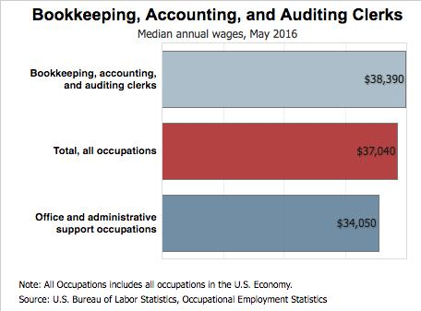What clerks get paid [Click to enlarge]
The median annual wage for bookkeeping, accounting and auditing clerks was $38,390 in 2016. The lowest 10 percent earned less than $23,880, and the highest 10 percent earned more than $59,630.
In May 2016, the median annual wages for bookkeeping, accounting and auditing clerks in the top industries in which they worked were as follows:
Professional, scientific and technical services - $40,140
Finance and insurance - $39,980
Wholesale trade - $38,910
Health care and social assistance - $37,760
Retail trade - $33,720
Many bookkeeping, accounting and auditing clerks might work longer hours to meet deadlines at the end of the fiscal year, during tax time, or when monthly or yearly accounting audits are performed. Those who work in hotels, restaurants and stores might put in overtime during peak holiday and vacation seasons.

Job Outlook
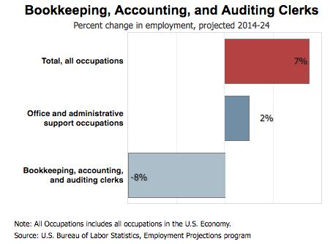How the number of jobs will change.[Click to enlarge]
Employment of bookkeeping, accounting and auditing clerks is projected to decline 8 percent between 2014 and 2024. Technological change is expected to reduce demand for these workers as more of clerks' work is done by computers.
Demand for bookkeeping is tied particularly to the growth of small businesses. These companies tend to hire bookkeepers rather than accountants due to their relatively lower cost.

Job Prospects
Bookkeeping, accounting and auditing clerks make up a large occupation of almost 2 million workers. Therefore, there will be a large number of job openings from workers leaving the field when they retire. Opportunities to enter the occupation should be plentiful.
Writing Prompt: Would you consider a career in this field? Why or why not? Use details from the article and from your personal life to explain your answer.

