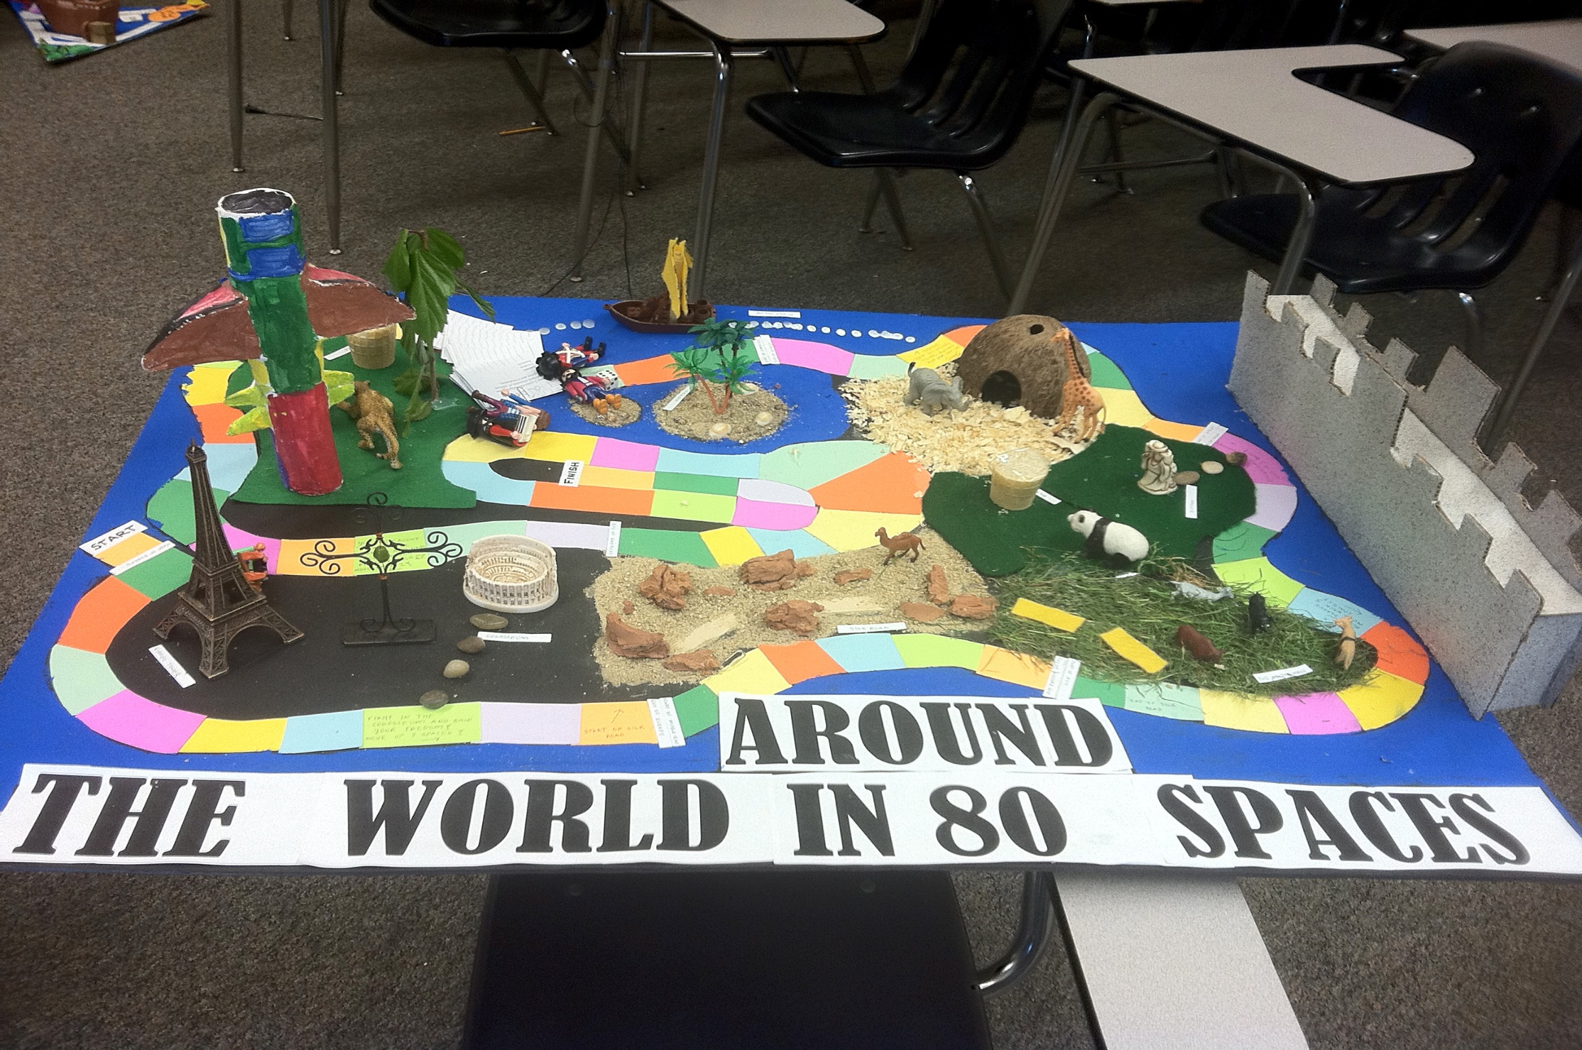

[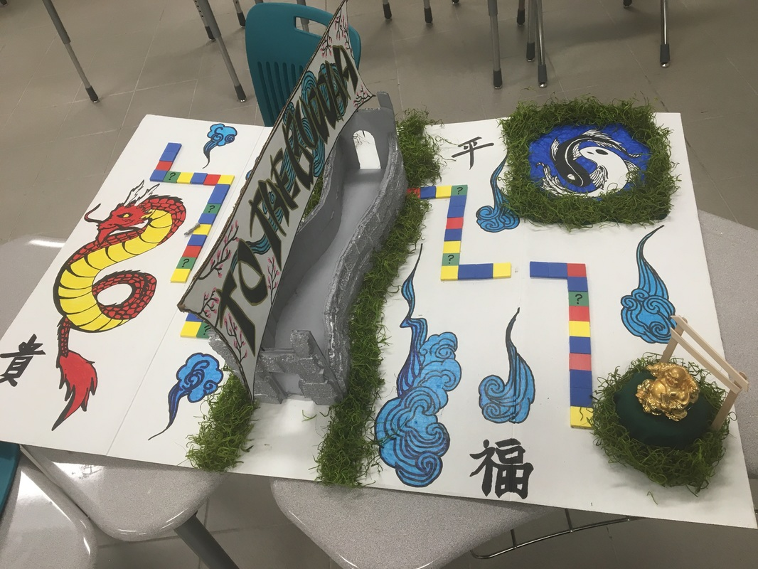](http://www.mrsamartinez.com/civilizations-board-game-project-spring-2016.html)

[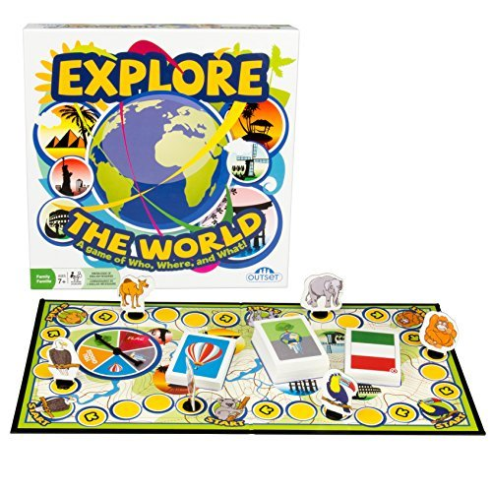](https://www.amazon.com/slp/around-the-world-game/3wmc7rko22h579c)

[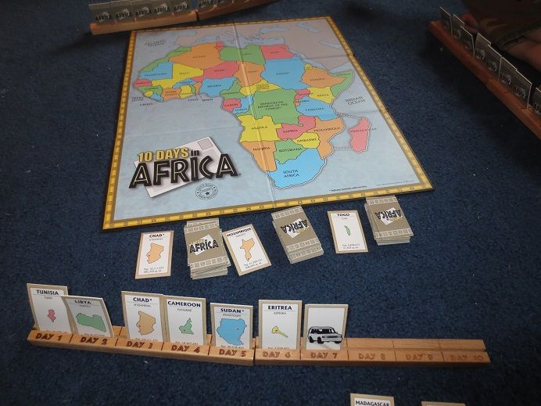](https://www.pinterest.com/explore/geography-games-for-kids/)

[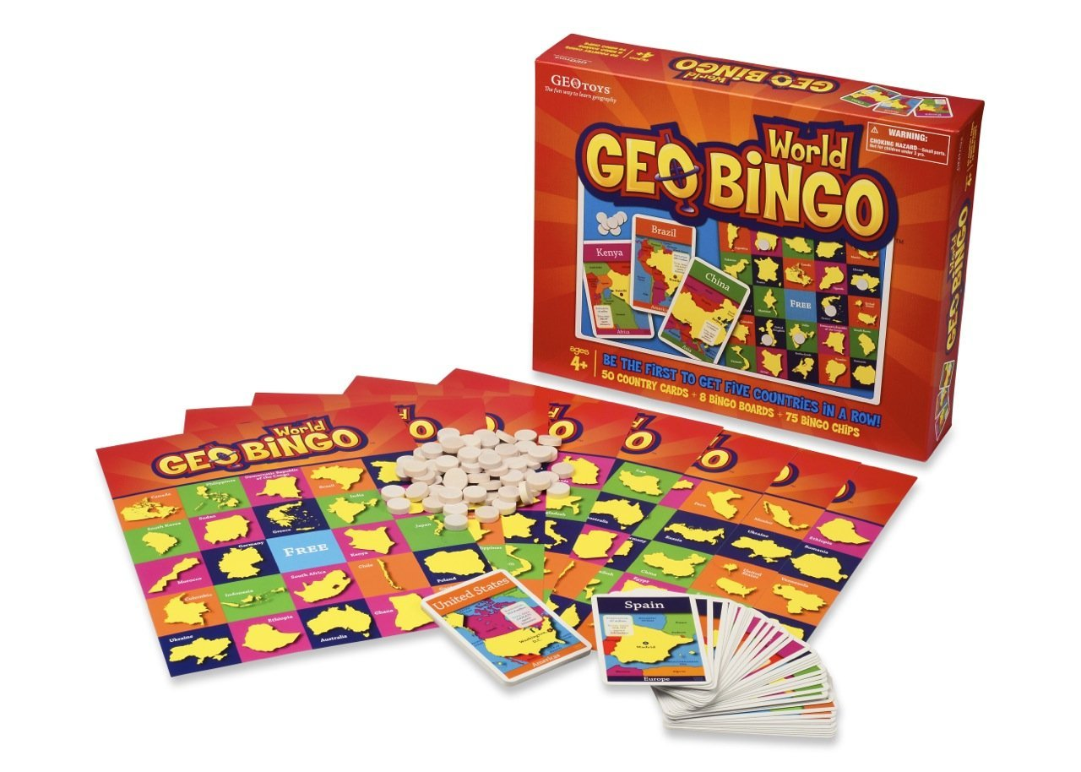](https://www.amazon.com/GeoBingo-World-Educational-Geography-Board/dp/B003CQ0LEE)

[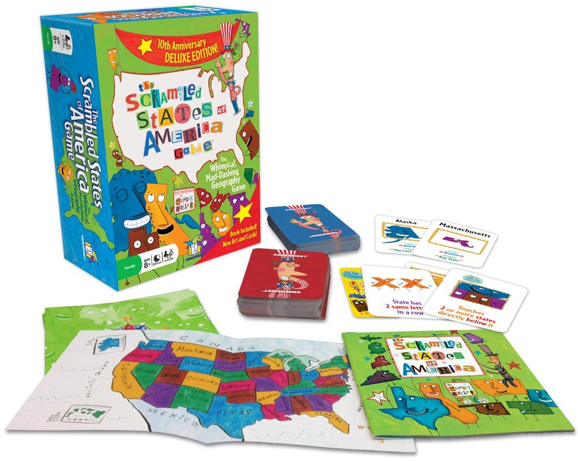](https://www.amazon.com/Gamewright-5505-Scrambled-States/dp/B0009XBY1W)

[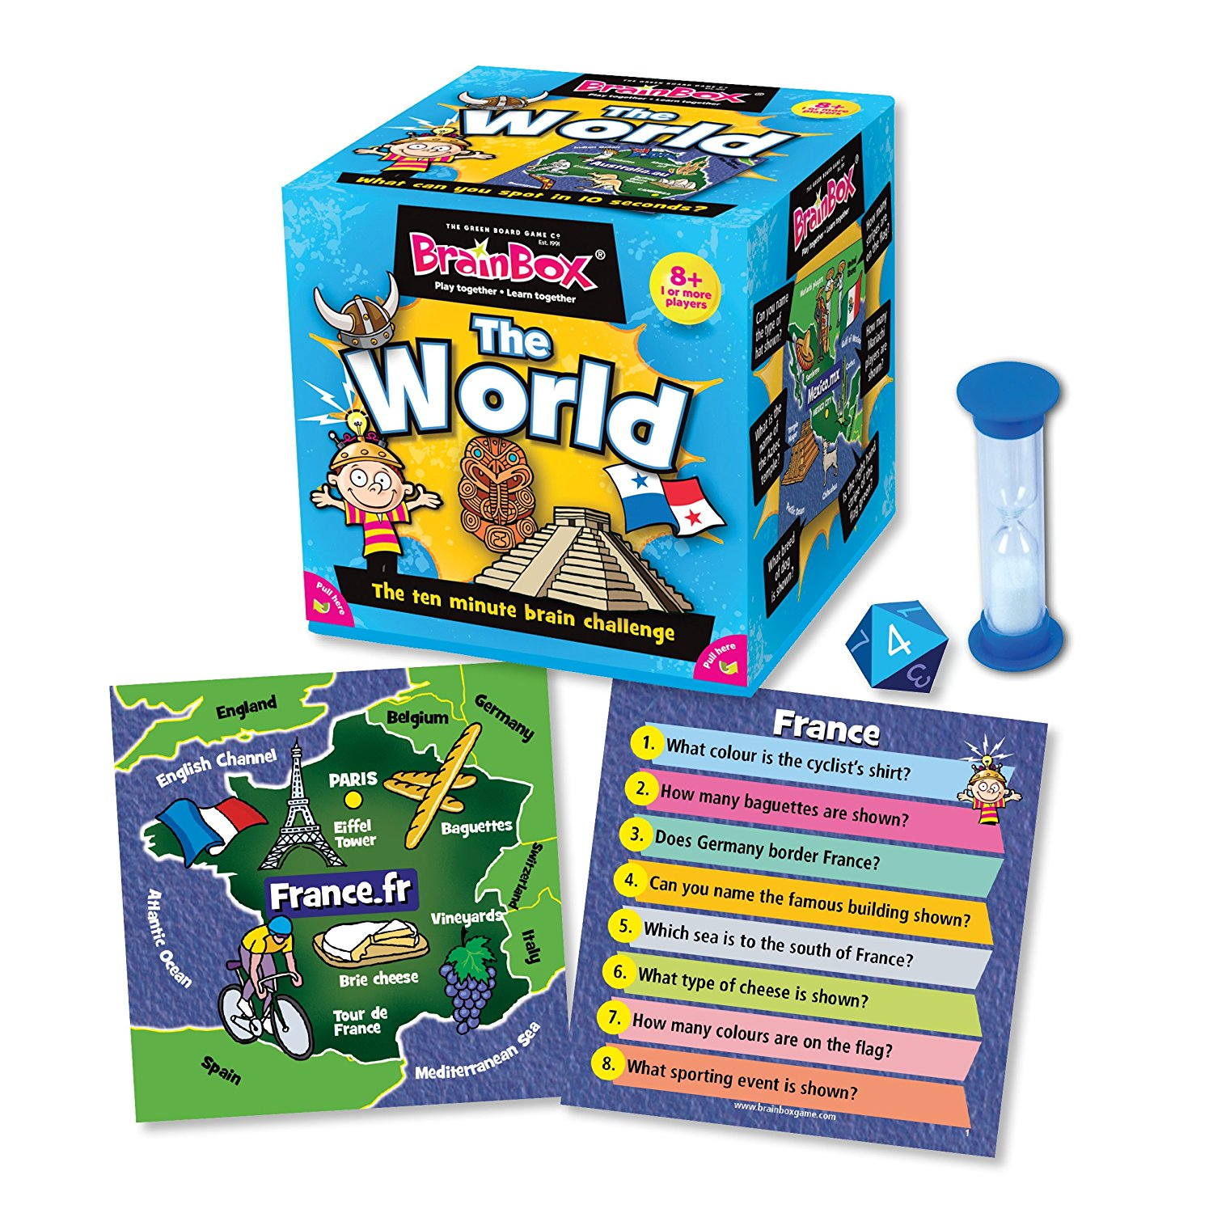](https://www.amazon.com/Brainbox-All-Around-The-World/dp/B000WA6KFW)