[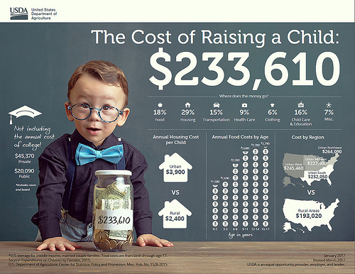](https://www.usda.gov/media/blog/2017/01/13/cost-raising-child)