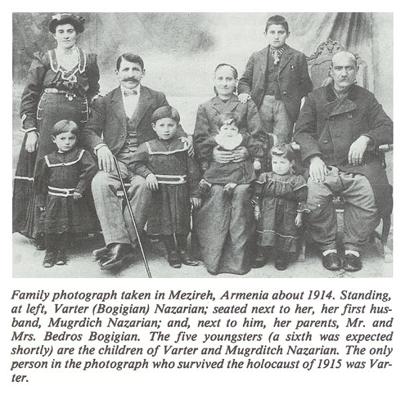
By Hagop Martin Deranian
Varter was born in 1885 in the lively village of Hussenig which, with its population of five thousand, was located in a valley a few miles below the flourishing and more urban city of Kharpert. It began with the ominous knock on the door in the middle of the night. The Turkish gendarmes said that they wished to make some immediate purchases in the Nazarian store. Mugrditch was not given time to dress but left his tranquil home dressed only in pajamas. Varter never saw her husband again. No one agreed on the precise fate of Mugrditch Nazarian. Some say he was taken out of town a few miles and shot. Others relate that he was among those who were imprisoned in Mezireh and exposed to inhuman tortures so unbearable that he and the other prisoners poured the kerosene from the jail lamps onto themselves and ended their lives as human pyres. A few days later, on June 11, the horror began for Varter, all the more frightening since she was nearly full term with another child. Ordered to prepare for “deportation”, she gathered her infirm in-laws, her maid Tamam, and her children, Eghisapet, Takouhi, Nazareth, Yeghsa, Arakel and Avedis. She obtained a donkey with a saddle bag with two pockets. In each pocket she placed one of her smallest children. The next day, the gendarmes pushed the donkey with its two children down a mountainside and to their deaths. “I saw Varter at noon”, a fellow companion tearfully recalled of that day, “and when I saw her again in the evening, I could not recognize her, She was almost naked”. “Elmas”, Varter said to her friend in utter anguish and pain, “let us find a well and throw ourselves into it”. At that moment of despair, some Arab woman took pity on her and drew some water from the well and quickly gave it to her before the gendarmes saw. They had been traveling in these terrible conditions for a month and a half since leaving Mezireh. One morning soon thereafter, Varter awoke with her children and saw that the caravan had moved on. Seizing the opportunity to hide, she descended into a dry well with her children. There she remained safely for two days without food. A passing Arab, some say a Pasha, came to the well and shouted into it, “If there is anyone down there, let him speak, as I am about to throw stones in the well”. “No, don't throw any stones”, Varter shouted, “I am here with my children”. “Very well” the Arab replied, “I will help you out”. Varter was relieved. “Help my children out one at a time”, she pleaded. “Then I will come”. “No!” the Arab emphatically responded. “You come first so that we may pull the children out together”. Hesitatingly and very slowly, Varter lifted herself out. Seeing her comeliness, the Arab seized her and forcibly adducted her. He was totally deaf to her appeals for her children left in the well. Their echoing voices cried after her, “Mother, Mother!” Those infant cries haunted and tormented her the remaining days and dark nights of her life. The dry hole became Varter’s wailing well.
M.Teranyan, Husseinik. Memories and Emotions about Native Hearth and People, Boston, 1981, pp.180-189 (arm)
STORY OF VERONIKA BERBERYAN
Yozghantsi Veronika Berberyan (born 1907) recalls the Turkish recruitment: “…Towards the evening on Saturday they gathered all the men to send them to the Turkish army, but there they separated Armenians from Turks.
My grandpa, Priest Hakob Berberyan, who was entrusted to protect the rights of the Armenians, seeing that Armenian and Turkish soldiers were being separated, asked “Why do you single out the Armenians?” The Turkish commander answered, “Papaz (priest) efendi, Armenians are to go work on road construction, and Turks are going to the Russian front”.
The next day was Sunday. My grandfather had just arrived at home after serving mass. Immediately, we learned about the horrible news. Artin Agha’s son was a miller. He woke up in the morning, went to work and there saw severed human heads and limbs near the mill. Shocked by the horror, he hurried to the house panting, and described what he had seen. Artin Agha and his son came and told my grandfather, “They have butchered the men they had called soldiers yesterday”. My grandfather instructed him, “Go, complain to the ghaymagham (governor)”. Artin Agha went to the ghaymagham to complain, but the latter had not returned home that night.
The next day, Monday, two Turkish gendarmes came with clubs. On previous occasions when gendarmes had come to our house, they had politely asked the priest efendi to get dressed and go with them. This time they came and rudely commanded, “Haide, kalkn” (now get up). They took my grandfather to the ghaymagham. With my grandfather they also took the local distinguished figures, tradesmen and the intellectuals. A Turk said to my grandfather, “Papaz efendi, your last hour is here, what do you have to say?” My grandfather fell on his knees and began to pray. A Turkish soldier then swung an axe and beheaded the priest. The soldiers then started to play football with the head of my grandfather…”
Verjine Svazlian. The Armenian Genocide: Testimonies of the Eyewitness Survivors. Yerevan, 2000, Testimony214, pp.353-354

“EH, IT WAS OUR LIFE”:
Tiruhi’s recollection of escape and resettlement
Tiruhi Khorozyan, 96, is one of the few living witnesses of the Genocide She was only six years old, but already perceived the words ‘enemy’ and ‘Turk’ as synonymous. She was too little to understand why it was so, but big enough to remember those bloody episodes and atrocities for the rest of her life.
Tiruhi remembers the day when she escaped the Turkish sword
Ninety years after 1915, Tiruhi speaks about the events in her native town of Adabazar in a way as if it was only yesterday when she miraculously escaped the enemy’s sword.
“We were escaping for two days through rocks and gorges and were so thirsty that our mouths had dried, we gasped for breath. My mother went downhill to fetch water from the gorge and came back terrified. The river had become red from the blood of the dead bodies thrown into it,” Tiruhi remembers.
Adabazar is a town situated in the northwest of Turkey. In 1915 it still had a population of about 30,000 people, more than half of whom were Armenians. They were mainly engaged in trade, crafts, husbandry and fruit-growing. There were four churches there with preparatory schools and gymnasiums attached to each of them.
Tiruhi remembers that they had a large orchard of mainly chestnut and walnut trees. “We had plenty of sacks of them in the yard,” she says.
Beginning in 1915 the Armenian population was displaced and killed on the road. Tiruhi’s father, Andranik Arzumanyan, was a fidayi, a guerilla as Tiruhi calls him, who helped people escape Turkish yataghans (swords).
“One day two Turkish soldiers caught my father who had me with him. He was seized and taken away, I was a little kid, and I lost my way,” says Tiruhi.
“The soldiers showed me the direction to get to home. I took that way and what I saw was murdered people, blood and deaths on all four sides. I didn’t know what to do, where to run. I was lucky that an elderly woman was passing by with two children, she took me and said she would take me to my mom.”

Remember 24 April, Yerevan, 2007 by www.ArmeniaNow.com

