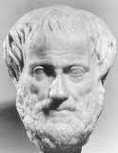[](javascript:edit(80906))

**Record Aristotle’s beliefs/ideas about government/democracy from the handout provided & you’re notes. Put the ideas/beliefs in your own words.**

**Aristotle in a bottle!**