[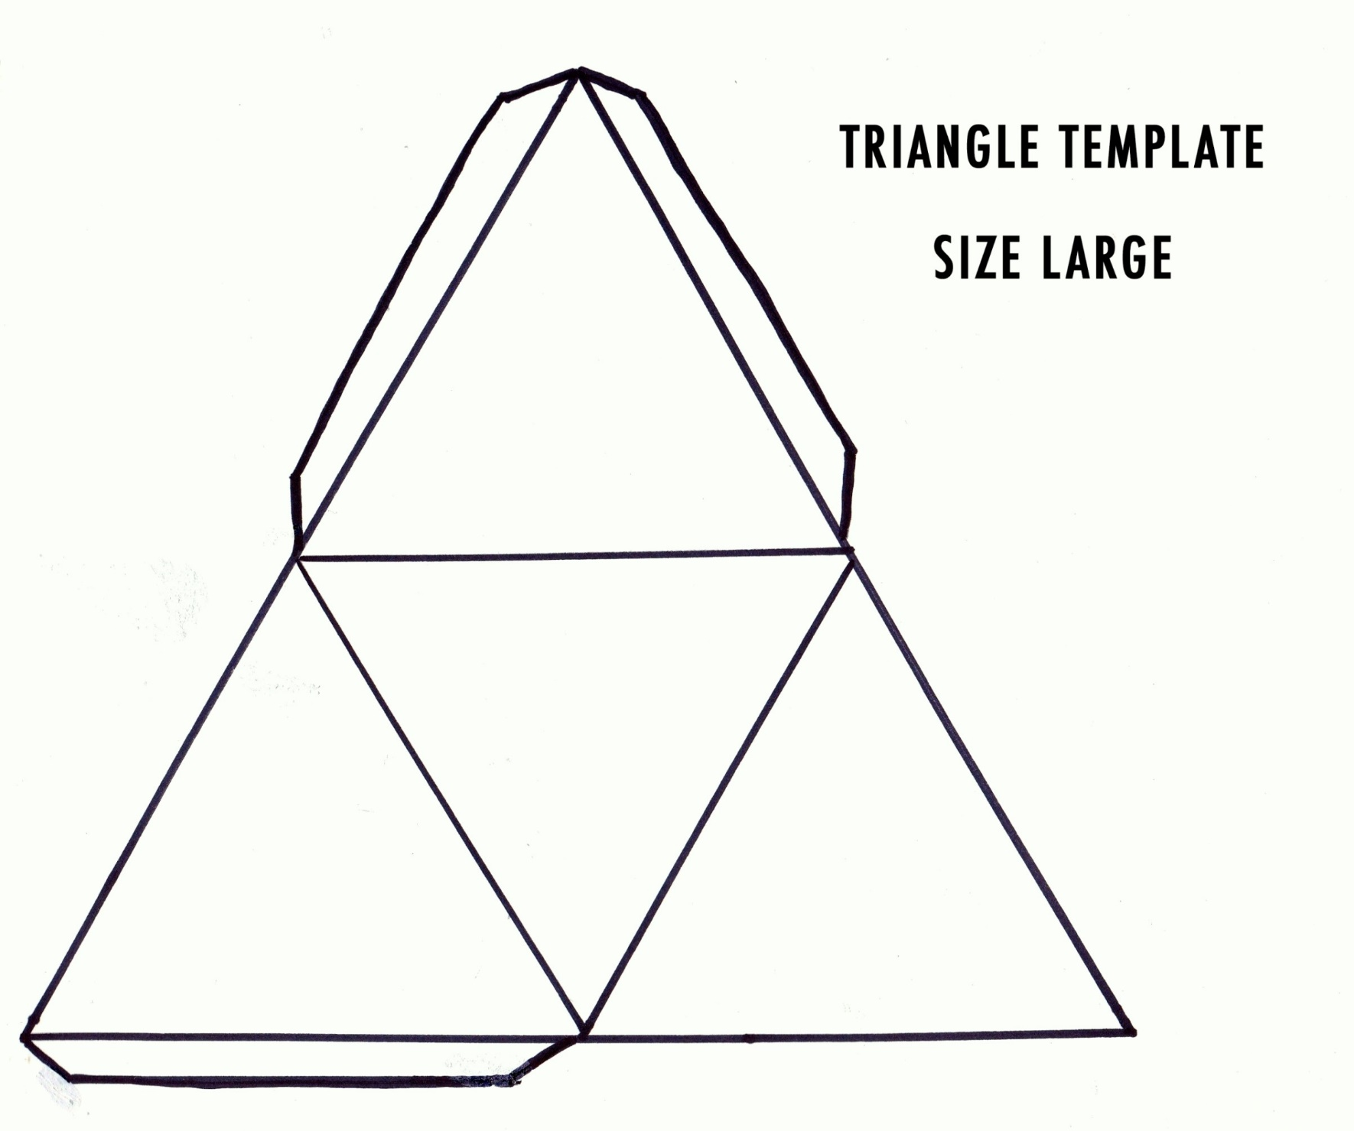](https://www.google.com/url?sa=i&rct=j&q=&esrc=s&source=images&cd=&ved=0ahUKEwih67PK883YAhVH3WMKHRbiDOwQjRwIBw&url=http%3A%2F%2Fwww.update234.com%2F3-sided-pyramid-template-printable.html&psig=AOvVaw365d1gB4nG8dotFGNOEOov&ust=1515691109618908)